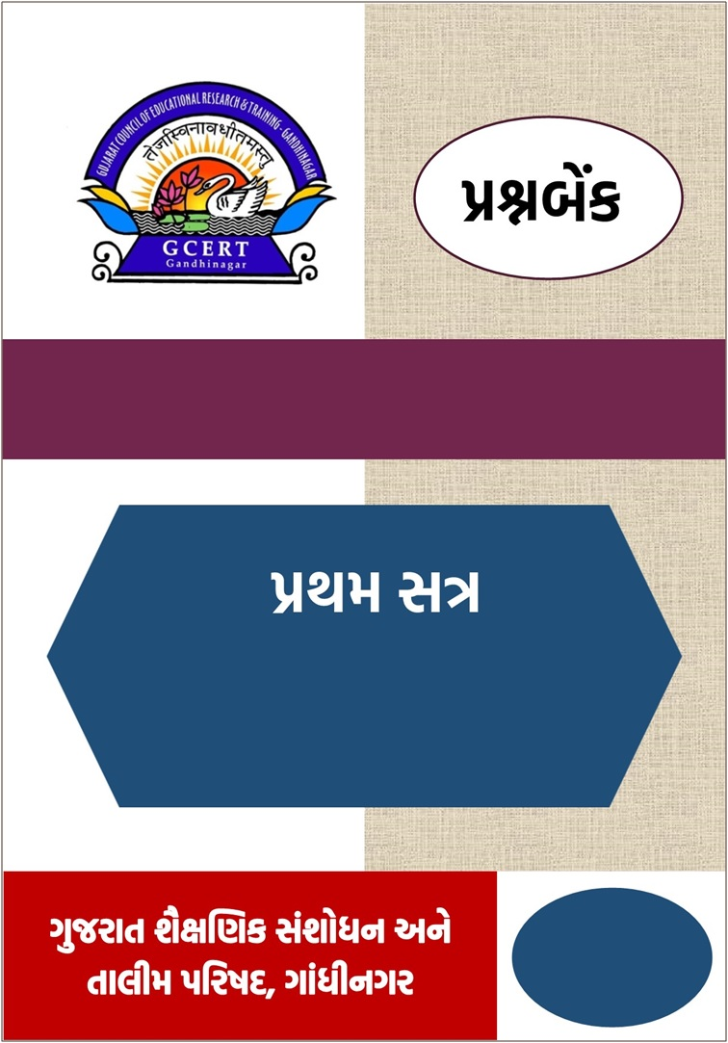

વિષય – અંગ્રેજી

પ્રકરણ: 1, 2
વર્ષ : 2025-26

ધોરણ-4

ધોરણ 4 (અંગ્રેજી) પ્રથમસત્ર પ્રકરણ (1,2) માં સમાવિષ્ટ LO ની યાદી

ક્રમ | LOs | વિધાન  ધોરણ-4  રણ – 4 | પેજ નં.
1 | E404 | વર્ગખંડમાં ઉપલબ્ધ લેખિત સામગ્રી /વસ્તુઓ તેમજ ઘર અને આસપાસના પર્યાવરણમાં રહેલી વિવિધ વસ્તુઓનું વર્ણન સાંભળે છે, સમજે છે, વાંચે છે અને ટૂંકમાં તેનું વર્ણન કરે છે. | 3
2 | E405 | લૉનવર્ડ્ઝ સહિત આશરે 400 જેટલાં શબ્દો જાણે છે, વાચનમાં રહેલા તે શબ્દો ઓળખે છે અને લેખનમાં તેનો ઉપયોગ કરે છે. | 8
3 | E406 | પ્રાસવાળા શબ્દો વાંચીને ઓળખે છે તેમજ તેની જોડ બનાવે છે અને તેમાં પ્રાસવાળા નવા બીજા શબ્દો ઉમેરે છે. વાચન અને ઉચ્ચાર વચ્ચેનો સંબંધ ઓળખે અને તારવે છે. | 13
4 | E408 | ટૂંકી પરિચિત વાર્તા સાંભળી પૂછેલી વિગતો/ પ્રશ્નોના જવાબ આપે છે. મુદ્દા કે ચિત્રની મદદથી વાર્તાનું વર્ણન કરે છે. | 16
5 | E411 | પોતાના માતા-પિતા, ભાઈ-બહેન અને મિત્રોનો સામાન્ય પરિચય આપે છે. | 21
6 | E414 | વસ્તુના કદ, આકાર, રંગ, સંખ્યા અને વજન વિશે ચારથી પાંચ શબ્દો / શબ્દસમૂહમાં જણાવે છે. | 25

C-2.2: મુદ્રિત સામગ્રીમાંથી લખાણના મૂળભૂત માળખાને સમજીને શબ્દો, વાક્યો અને વિરામચિહ્નોની ઓળખ રજૂ કરે છે.
E404: વર્ગખંડમાં ઉપલબ્ધ લેખિત સામગ્રી /વસ્તુઓ તેમજ ઘર અને આસપાસના પર્યાવરણમાં રહેલી વિવિધ વસ્તુઓનું વર્ણન સાંભળે છે, સમજે છે, વાંચે છે અને ટૂંકમાં તેનું વર્ણન કરે છે.

Objective type questions
Q.1 Study the picture. Choose the most appropriate option. (Each question carries one mark.) (15)
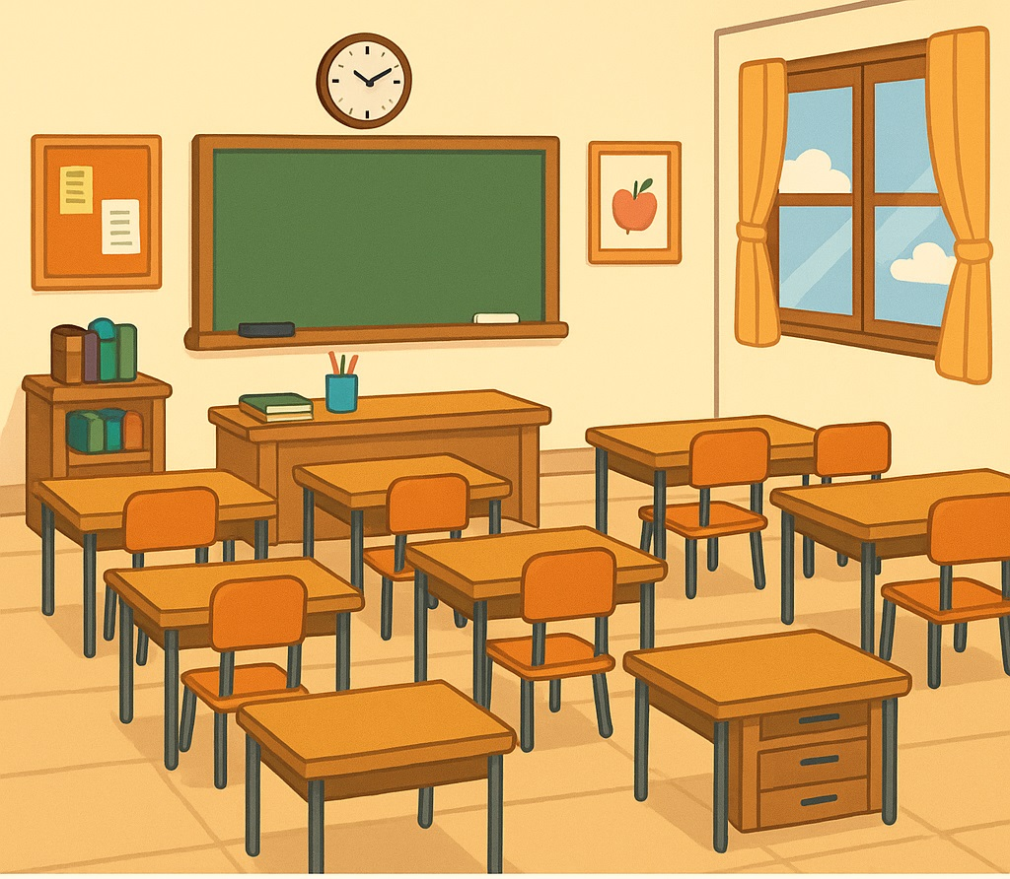

- How many teacher’s table are there?
(A) four (B) six (C) eight (D) one
- How many legs does a desk have?
(A) two (B) one (C) four (D) three
- How many windows are there?
(A) one (B) two (C) three (D) four
- How many chairs can you see?
(A) five (B) seven (C) nine (D) ten
- How many books are there on the teacher's table?
(A) zero (B) one (C) two (D) three
- How many pens are there in the cup?
(A) one (B) two (C) three (D) four
- How many clocks are on the wall?
(A) zero (B) one (C) two (D) three
- How many pictures are there on the wall?
(A) zero (B) one (C) two (D) three
- How many bags are there on the desk? (HOT)
(A) zero (B) two (C) three (D) four
- How many bulletin boards are there?
(A) zero (B) one (C) two (D) three
- How many curtains can you see?
(A) one (B) two (C) three (D) four
- How many drawers does the last desk have? (HOT)
(A) one (B) two (C) three (D) four
- How many lamps are there in the classroom? (HOT)
(A) zero (B) one (C) two (D) three
- How many apples are there in the frame?
(A) two (B) three (C) four (D) one
- How many papers are there on the bulletin board?
(A) one (B) two (C) three (D) four
Q.2 Match ‘A’ with ‘B’. (Each question carries one mark.) (05)
A | B | Answer
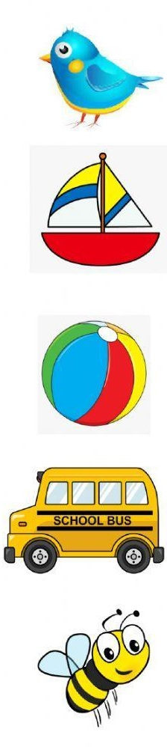1. | (A) ball | 1. ___
2. | (B) bus | 2. ___
3. | (C) boat | 3. ___
4. | (D) bee | 4. ___
5. | (E) bird | 5. ___

Q.3 Complete the words. (Each question carries one mark.) (05)
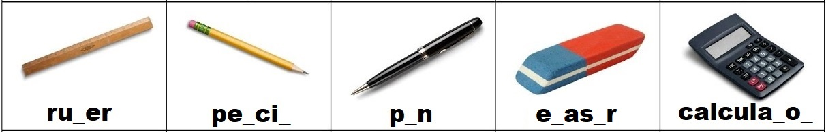(e; l; t-r; n-l; r-e)
Very short answer questions

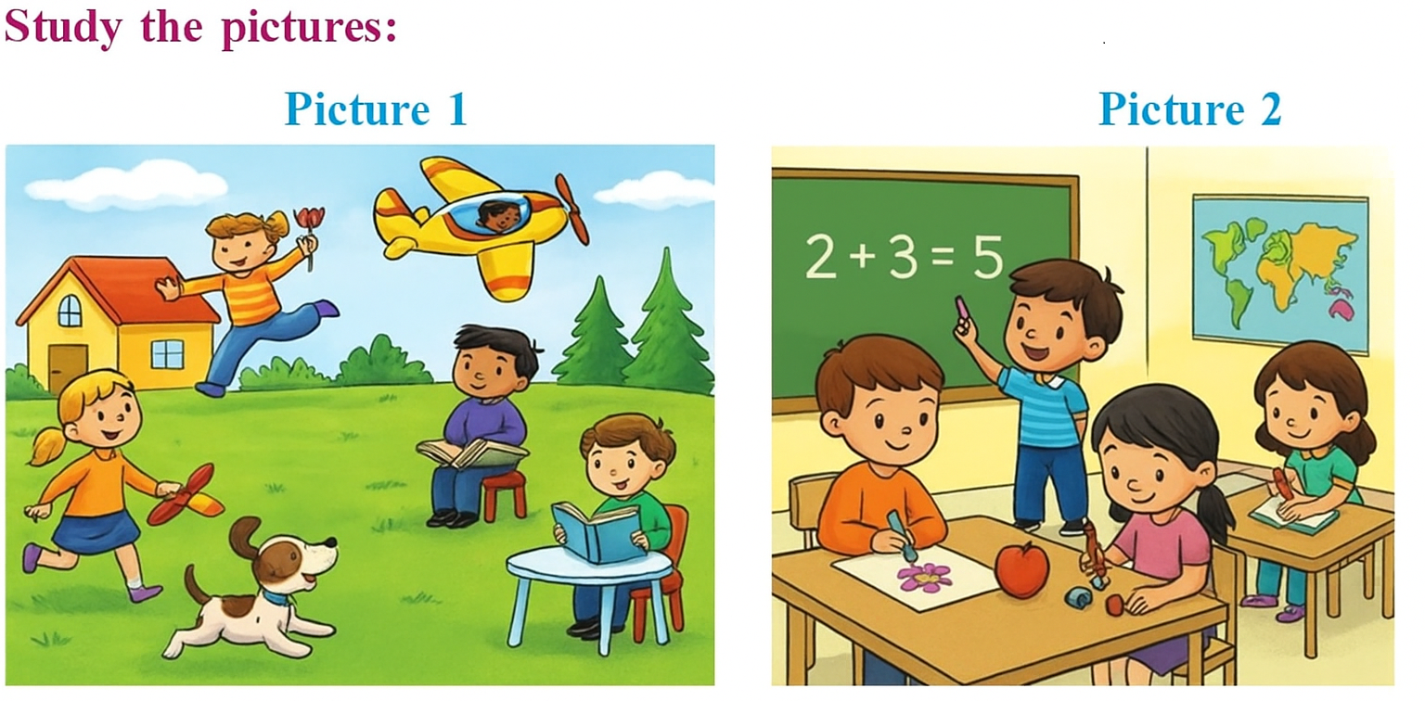Q.1 Read the sentences. Write 1 if it is related to picture 1 and write 2 if it is related to picture 2. (HOT) (Each question carries one mark.) (05)

- A dog is running. _____
- There is a map on the wall. _____
- A boy is sitting on chairs. _____
- Two girls are sitting on chairs. _____
- A boy is drawing a picture. _____

Q.2 Study the picture and answer the question. (HOT) (Each question carries one mark.) (05)

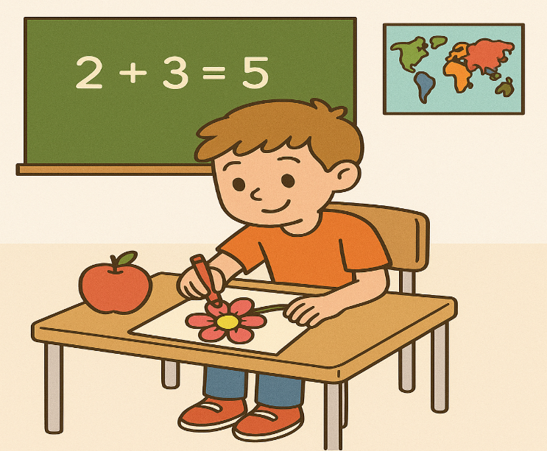

- The boy is drawing a __________. (fruit, flower)
- There is a/an__________ on the table. (apple, banana)
- The boy is sitting on a chair. (True / False)
- There is a car in the picture. (True / False)
- The chalkboard shows __________________. (2+2=5, 2+3=5)
Essay type questions
Q.1 Study the diagram and complete the table. (Each question carries one mark.) (HOT) (05)
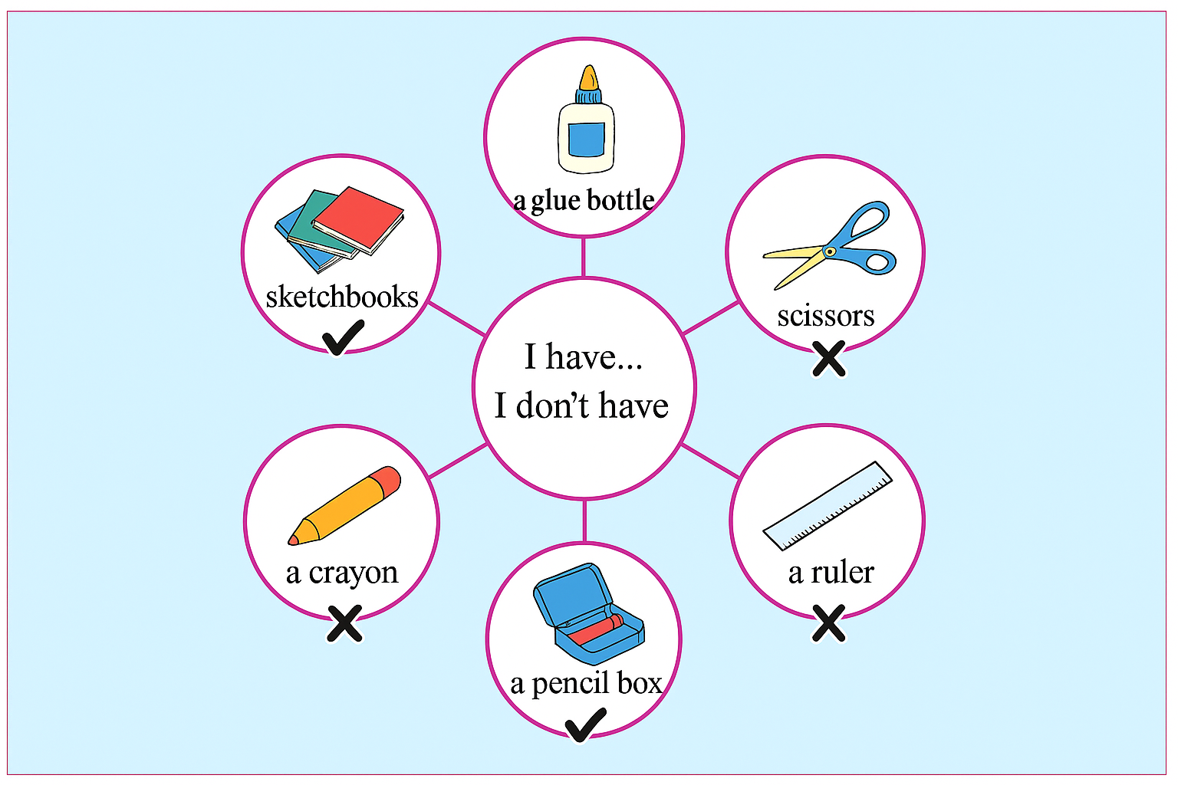

I have… | I don’t have…
I have a glue bottle in my bag. | I don’t have __________ in my bag.
I have __________ in my bag. | I don’t have ________________________.
_____________________________. | ___________________________________.

Q.2 Study the table and make sentences. (Each question carries one mark.) (HOT) (05)

Thing  Persons | book | sharpener | compass box
I | √ | × | √
Radha | × | √ | ×

I have… | Radha has…
I have a book. | Radha does not have ___________.
I do not have ___________________. | Radha has ____________________.
_____________________________. | ___________________________________.

C-4.1: બીજાં અભ્યાસક્ષેત્રોની મુદ્રિત સામગ્રી સાંભળીને અને વાંચીને શબ્દોના અર્થોની ચર્ચા કરે છે અને શબ્દભંડોળનો વિકાસ (અભિવ્યક્તિ મારફતે) દર્શાવે છે.
Learning Outcome: E405: લૉનવર્ડ્ઝ સહિત આશરે 400 જેટલાં શબ્દો જાણે છે, વાચનમાં રહેલા તે શબ્દો ઓળખે છે અને લેખનમાં તેનો ઉપયોગ કરે છે.

Objective type questions
Q.1 Choose the most appropriate option. (Each question carries one mark.) (15)
- Choose the correct spelling:
(A) bukk (B) buk (C) book (D) boook
- The opposite of 'hot' is _______.
(A) cold (B) warm (C) red (D) big
- Complete the word: 'ta_ _ _' (used for study)
(A) ber (B) ble (C) bla (D) bel
- We use it to write: _________
(A) pen (B) cap (C) cup (D) map
- Find the odd one out.
(A) spoon (B) plate (C) bowl (D) ball
- The correct ending for this word: 'Festi____'?
(A) let (B) gle (C) val (D) tag
- He cuts fruits with a '____'.
(A) door (B) fan (C) bottle (D) knife
- Choose the correct sentence:
(A) I drink milk with a pencil. (B) I drink milk with a book.
(C) I drink milk with a cup. (D) I drink milk in a bag.
- Find the word that is similar to 'fast':
(A) slow (B) quick (C) big (D) short
- Choose the word that is different from the others:
(A) school (B) teacher (C) chalk (D) banana
- Complete the word: 'ch_ _ _' (used to sit)
(A) air (B) oor (C) eat (D) ark

- The opposite of 'small' is ________
(A) short (B) tiny (C) big (D) low
- Choose the correct spelling:
(A) craker (B) krackers (C) crackers (D) ckrackers
- I see at the ________ to see the time.
(A) clock (B) sock (C) lock (D) block
- Select the correct word:
She cleaned the floor with a '____'.
(A) mop (B) cup (C) mat (D) tap
Q.2 Match A with B. (Each question carries one mark.) (05)

A | B | Answer
- seumo | a. wheel | 1.___
- oungrd | b. land | 2.___
- fylettbur | c. mouse | 3.___
- dnal | d. butterfly | 4.___
- lhewe | e. ground | 5.___

Q.3 Circle the odd one. (Each question carries one mark.) (05)
- elephant monkey sparrow rabbit
- banana mango, potato grapes
- cow parrot peacock crow
- pen pencil bat eraser
- car bus train school

Very short answer questions
Q.1 Arrange the following words in the alphabetical order. (Each question carries one mark.) (05)
free, train, around, down, juice
-----------, -----------, -------------, ------------, ------------

Q.2. Make a pair of opposite words from the brackets. (HOT) (Each question carries one mark.) (05)
(hot, close, night, cold, day, sad, out, happy, open, in)
- __________ × __________
- __________ × __________
- __________ × __________
- __________ × __________
- __________ × __________

Short answer questions
Q.1 Answer in one word. (HOT) (Each question carries two marks.) (05)
(a dog, a chair, a book, a clock, a pen)
- I have hands but no fingers.
I show you the time.
What am I? __________
- I bark but I am not a tree.
I am a pet.
Who am I? __________
- I have four legs but I can’t walk.
You sit on me.
What am I? __________
- You use me to write.
I have ink inside me.
What am I? __________
- I live in your school bag.
I open and close, and I have pages.
What am I? __________

Q.2 Study the picture and complete the sentences. (Each question carries one mark.) (05)

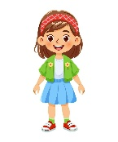  Rima | 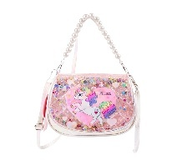  a purse | Rima’s purse | Ans. This is Rima’s  purse.

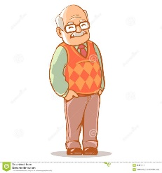Grandfather | 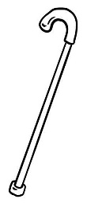a stick | Grandfather’s stick
 Rohit | 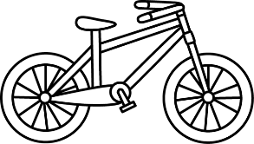  a bicycle | Rohit’s bicycle
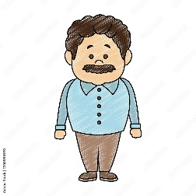My father | 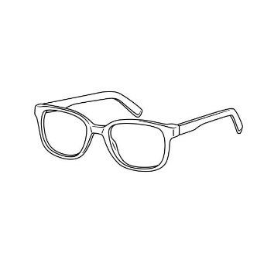  spectacles | My father’s spectacles
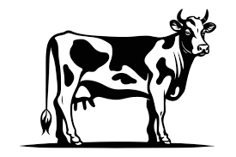  Gauri | 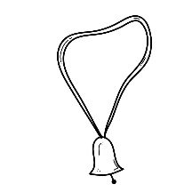a cowbell | Gauri’s cowbell
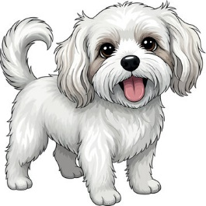  Tommy | 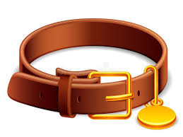  a belt | Tommy’s belt

Essay type questions

Q.1 Look at the picture and complete the paragraph. Use the words given in the brackets. (Each question carries one mark.) (10)

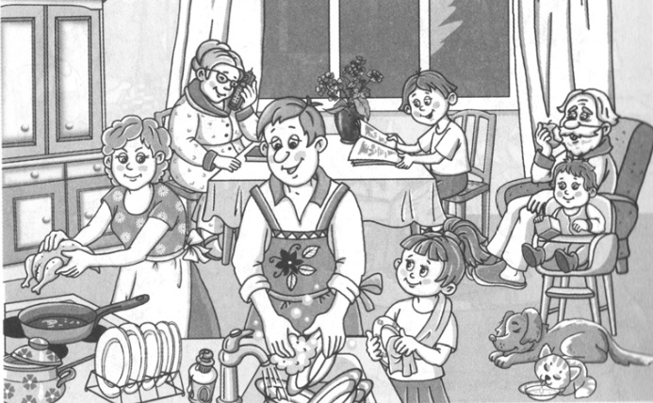

(washing, pets, talking, sleeping, kitchen, wiping, seven, drinking, eating, reading)
This is a picture of a _______. There are _______members in the family. Father is _______dishes. The grand father is _______an apple. There are two _______. The dog is_______. The cat is _______milk. The young girl is _______the dish. The young boy is _______a book. Grandmother is _______on the phone.

C-2.1: ધ્વનિને શબ્દોમાં મિશ્રિત કરીને અને શબ્દોને ધ્વનિમાં વિભાજિત કરીને ધ્વનિ જાગૃતિનો વિકાસ પ્રદર્શિત કરે છે.
Learning Outcome: E406: પ્રાસવાળા શબ્દો વાંચીને ઓળખે છે તેમજ તેની જોડ બનાવે છે અને તેમાં પ્રાસવાળા નવા બીજા શબ્દો ઉમેરે છે. વાચન અને ઉચ્ચાર વચ્ચેનો સંબંધ ઓળખે અને તારવે છે.

Objective type questions
Q.1 Choose the most appropriate option. (Each question carries one mark.) (15)
- Choose the word that rhymes with cow.
(A) car (B) now (C) cup (D) cold
- Choose the pair that has the same ending sound. (HOT)
(A) ear – tear (B) dog – pen (C) fish – four (D) tail – ten
- One word does not rhyme with the others.
(A) big (B) dig (C) pig (D) pen
- Choose the rhyming word for ‘tail’.
(A) tall (B) nail (C) tell (D) tool
- Choose the word that rhymes with ‘white’.
(A) write (B) wait (C) wet (D) wide
- Add a rhyming word for ‘make’.
(A) much (B) mask (C) cake (D) milk
- Look at the list: hen, cup, pen, ten
The word that sounds different is _____.
(A) hen (B) pen (C) ten (D) cup
- A word rhymes with ‘game’.
(A) gum (B) same (C) go (D) gave
- Complete the sentence with a rhyming word: (HOT)
Four on the floor, I open the _____.
(A) door (B) book (C) frog (D) shoe
- Choose one word that does not end the same way. (HOT)
(A) you – too (B) cow – how (C) pen – game (D) big – dig
- Find the odd one out.
(A) play (B) day (C) say (D) make
- Choose a rhyming match for ‘sandal’.
(A) candle (B) travel (C) camera (D) pencil
- Choose the word that rhymes with ‘four’.
(A) fun (B) far (C) fear (D) door
- Choose the correct rhyming set.
(A) pen – pan – pin (B) big – bag – bug
(C) tail – nail – sail (D) game – gum – gem
- Fill in the blank with a rhyming word: (HOT)
You see me, I see a _____.
(A) bee (B) yes (C) new (D) use
Q. 2 Match ‘A’ with ‘B’ and make rhyming pairs. (Each question carries one mark.) (05)
‘A’ | ‘B’ | Answer
1.wood | a. say | 1.
2.land | b. town | 2.
3.day | c. mart | 3.
4.down | d. good | 4.
5.cart | e. band | 5.

Q.3 Write ‘True’ or ‘False’. (Each question carries one mark.) (05)
- ‘Toy’ is the rhyming word for ‘boy’. __________
- ‘Wheel’ is the rhyming word for ‘fell’. __________
- ‘Go’ is the rhyming word for ‘to’. __________
- ‘Lot’ is the rhyming word for ‘let’. __________
- ‘Care’ is the rhyming word for ‘dare’. __________

Very short answer questions
Q.1 Answer in one word. (Each question carries one mark.) (05)
(gun, bit, fan, cook, far)

‘Book’ is rhyming with ...............

‘Car’ is rhyming with .................

‘Pen’ is rhyming with ................. (HOT)

‘kit’ is rhyming with .................

‘Fun’ is rhyming with .................
Q.2 Find out the rhyming words from the paragraph. (HOT) (Each question carries one mark.) (05)
Sheru saw that his quills had made holes in his special new shirt. Feeling sad. Sheru went back to his only friend, the little mouse.

- this - ...........
- bad -..........
- few -..........
- lack -..........
- law - ..........

Short answer questions
Q.1 Read the poem and answer the questions. (Each question carries two marks.) (10)
Tom’s Dog
Tom has a dog,
It sits on a log.
They run in the sun,
And play for fun.
The dog sees a cat,
It looks so fat!
Tom says, “Let’s go,”
They walk too slow.
- Find the rhyming word for ‘cat’. __________
- The word ‘fun’ rhymes with __________
- ‘Go’ is the rhyming word for ‘slow’. ‘True’ or ‘False’ __________ (HOT)
- Complete the sentence with a rhyming word: Tom has a dog, It sits on a __________.
- How many rhyming pairs are there in the poem?
Q.2 Read the paragraph and answer the questions. (Each question carries one mark.) (05)
Geeta went to the park with her bag. She sat on the grass and took out a snack. She saw a cat chasing a rat. Then, a boy flew a red flag and slipped on a rag. Geeta smiled and put everything back in her bag.
- ________ word rhymes with "cat".
(A) grass (B) rat (C) snack (D) back
- True or False:
The word flag rhymes with rag.
- Fill in the blank:
Geeta took out a ______.
- Choose the rhyming pair from the paragraph:
(A) grass – snack (B) park – bag (C) snack – back (D) cat – grass
- Complete the sentence with a rhyming word from the paragraph:
The boy flew a red flag and slipped on a ______.

C-2.4: વાર્તાઓ, કવિતાઓ અને વાર્તા પોસ્ટરોનું અર્થગ્રહણ કરે છે.
Learning Outcome: E408: ટૂંકી પરિચિત વાર્તા સાંભળી પૂછેલી વિગતો/ પ્રશ્નોના જવાબ આપે છે. મુદ્દા કે ચિત્રની મદદથી વાર્તાનું વર્ણન કરે છે.

Objective type questions
Study the pictures and do as directed. (Each question carries one mark.) (15)
4
3
2

1
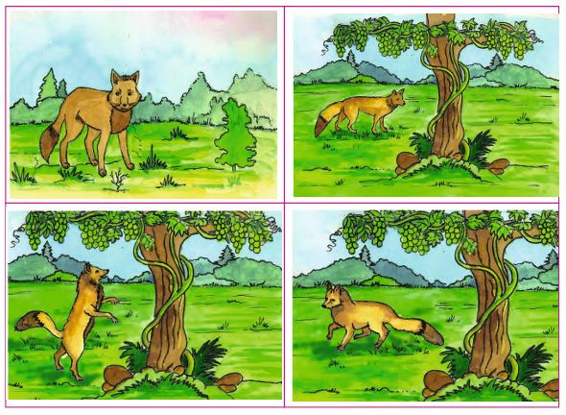
Q.1 Choose the most appropriate option.
- The animal in the picture is a ______
(A) cat (B) fox (C) dog (D) bear
- The fox is looking at the___________ in the third picture.
(A) grapes (B) apples (C) flowers (D) bananas
- Which of the following is not found in the story? (HOT)
(A) fox (B) tree (C) river (D) grapes
- What does the fox want?
(A) to eat grapes (B) to climb (C) to sleep (D) to dig the ground
- The fox tries to _______
(A) fly (B) jump (C) swim (D) sing
- What is the colour of the fox?
(A) black (B) grey (C) brown (D) white
- The grapes are ______
(A) low (B) on a table (C) small (D) high
- In the last picture, the fox is…
(A) happy (B) sleeping (C) going away (D) eating
- The fox cannot (HOT)
(A) get the grapes (B) sleep (C) walk (D) find the tree
- How many pictures are there?
(A) two (B) three (C) four (D) five
- The story shows the fox is ______
(A) clever (B) lazy (C) strong (D) hungry
- The grapes are hanging on _____
(A) a vine (B) a chair (C) a wall (D) a bag
- The fox jumps
(A) once (B) two times (C) many times (D) never
- There are no grapes in the _______ picture. (HOT)
(A) first (B) second (C) third (D) forth
- The fox is _______ in the last picture. (HOT)
(A) sad (B) happy (C) excited (D) all of the above
Q.2 Fill in the blanks using the most appropriate options. (Each question carries one mark.) (05)
(vine, get, tired, forest, juicy)
- The fox was walking in the __________.
- The grapes were hanging on a __________. (HOT)
- The grapes looked __________ to the fox.
- The fox tried but he could not __________ the grapes.
- The fox felt __________ after jumping for many times. (HOT)
Q.3 Write ‘True’ or ‘False. (Each question carries one mark.) (05)
- The fox sat under the tree and waited.
- The fox wanted to eat the grapes.
- The grapes were low and easy to reach.
- The fox was tired and walked away.
- The grapes looked juicy and sweet.
Very short answer questions
Study the pictures and do as directed.

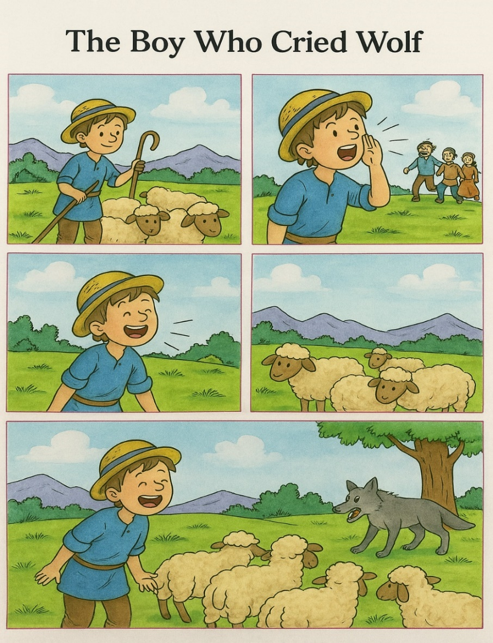
A Real Wolf!
2
1
There was a boy.
He was looking after his sheep near a village.
The boy was bored.
He shouted, “Wolf! Wolf!”
The people ran to help him.
But there was no wolf.
The boy laughed.
3
4
He shouted “Wolf!” again.
The people came again.
But there was no wolf.
They were angry.
One day, a real wolf came.
The boy shouted, “Wolf! Wolf!”
But no one came.
The wolf scared the sheep.
The boy was sad.
5
The boy learned a lesson:
Never tell a lie.

Q.1 Answer the questions in one word. (Each question carries one mark.) (05)
- Who was looking after the sheep? __________
- What did the boy shout? __________
- Did the people come to help him? __________
- Was there really a wolf at the first time? __________
- What came at the end of the story? __________

Q.2 Complete the sentences using the words given into the brackets. (Each question carries one mark.) (05)
(four; wolf! wolf!; sheep; help; wolf)
  - The boy was looking after __________. (HOT)
  - He shouted, “__________”
  - The people ran to __________ him.
  - There are ________ sheep in the last picture.
  - A real __________ came at the end.
Short answer questions
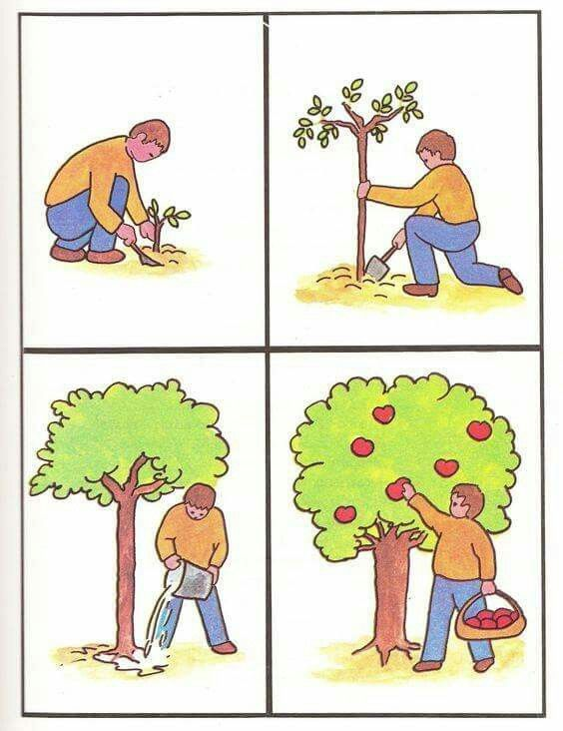
Study the pictures and do as directed.
2
1

4
3

Q.1 Write proper number of picture against the sentences. (Each question carries one mark.) (05)
_______ | a. | He watered the tree.
_______ | b. | He planted a small tree.
_______ | c. | He picked apples from the tree.
_______ | d. | He dug the soil near the tree.
_______ | e. | The tree grew big and strong.

Q.2 Fill in blanks with the words given in the brackets. (Each question carries one mark.) (05)
(water, tree, apples, soil, kind)
Ramubhai is very_____. He planted a small ______ in the ground. He dug the _____ to make it soft. He took a bucket and filled it with______. He watered the plant. The plant grew up. There were many ______ on it. He picked the apples. He kept the apples in the basket.

Essay answer questions
Q.1 Study the picture story and answer the questions that follows. (Each question carries two marks.) (10)
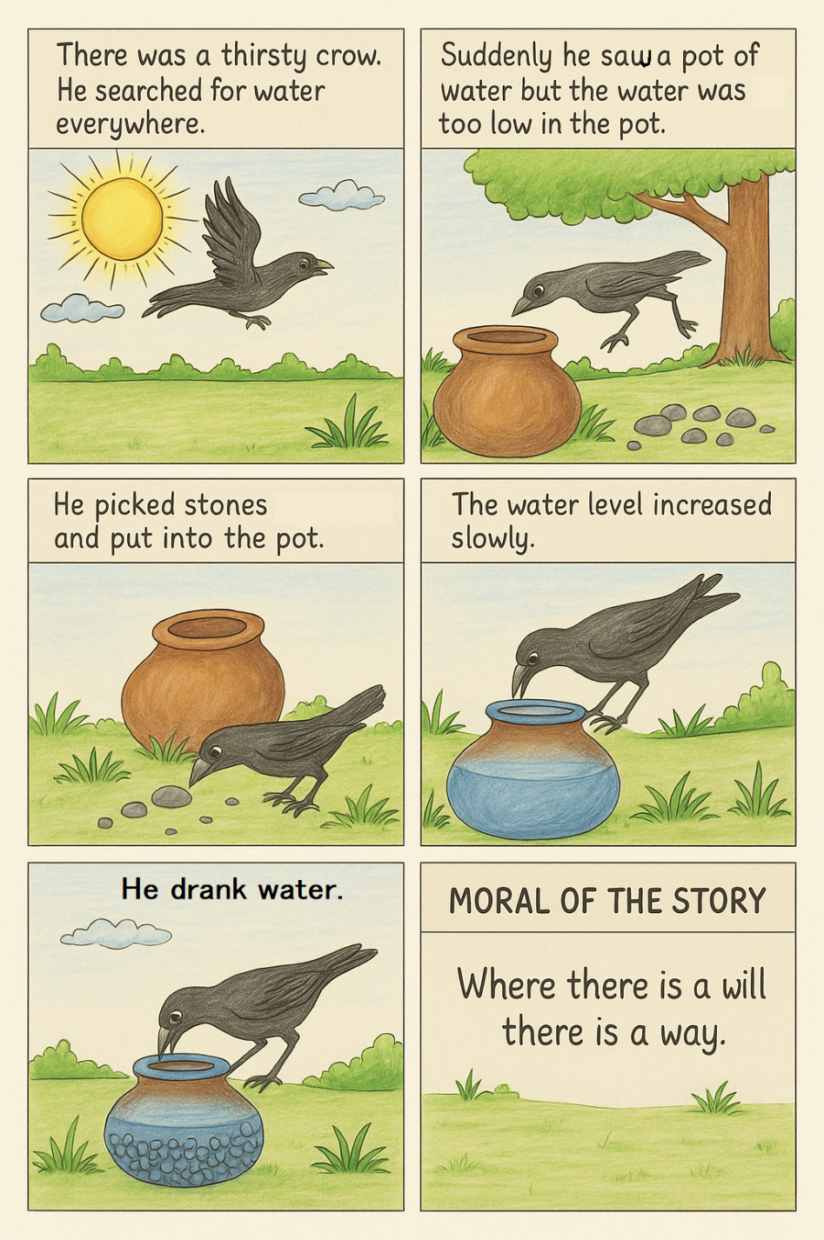

  - Who was looking for water?
  - Where did the crow put the stones?
  - The crow found a pot. True or false?
  - The crow drank the __________.
  - What did the crow do to make the water come up?

C-1.3: અર્થપૂર્ણ અને સુસંગત રીતે વાતચીત કરે છે.
Learning Outcome: E411: પોતાના માતા-પિતા, ભાઈ-બહેન અને મિત્રોનો સામાન્ય પરિચય આપે છે.

Objective type questions
Q.1 Choose the most appropriate options. (Each question carries one mark.) (15)
- Fill in the blank:
"She is my '____'. We play together every day."
(A) sister (B) father (C) brother (D) uncle
- Introduce your brother.
(A) This is my father. (B) She is my cousin.
(C) He is my brother. (D) I am his uncle.
- Choose the correct reply:
Q: Who is she?
(A) He is my mother. (B) She is my sister.
(C) I am your friend. (D) He is playing.
- Select the correct sentence: (HOT)
(A) My friend is a table. (B) My brother eats books.
(C) My sister is in Class 3. (D) My aunt is a small.
- Fill in the blank:
"I love my ____. He brings me chocolates." (HOT)
(A) chair (B) father (C) mother (D) sister
- What will you say when you meet your friend in the morning?
(A) Good night! (B) See you!
(C) Good morning! (D) What is this?
- Choose the best question to ask:
____ is your best friend?
(A) What (B) How (C) Who (D) When
- Select the correct sentence to describe your mother:
(A) She is my mother. She cooks food. (B) She is my sister. She helps me.
(C) She is my aunt’s daughter. (D) She is my father’s mother.

- Fill in the blank: "That is my ____. She is my father’s sister." (HOT)
(A) sister (B) friend (C) aunt (D) mother
- How do you answer this question:
Q: Is he your brother?
(A) Yes, she is. (B) No, I am. (C) No, it is. (D) Yes, he is.
- Choose the correct spelling:
(A) freind (B) frend (C) friend (D) friand
- What will you say when your friend helps you?
(A) Go away! (B) Thank you! (C) Sit down! (D) Don’t come!
- Fill in the blank: "My ____ helps me with my homework. He is very kind."
(A) brother (B) mother (C) sister (D) door
- Choose the correct question?
(A) What your name is? (B) Who your brother is?
(C) What is your name? (D) Name what is your?
- Choose the best way to introduce yourself:
(A) I am fine. (B) My name is Riya. (C) What is this? (D) Sit here.
Q.2 Write ‘True’ or ‘False’. (Each question carries one mark.) (HOT) (05)
  - My father is my mother’s husband.
  - My brother is my father’s daughter.
  - My uncle is my mother’s brother.
  - My brother is my grandfather.
  - My aunt is my father’s sister.
Q.3 Match ‘A’ with ‘B’. (Each question carries one mark.) (05)

A (Relation) | B (Who are they?) | Answers
1. uncle | a. a girl in my family like me | 1.___
2. aunt | b. my father's or mother's sister | 2.___
3. cousin | c. my father's or mother's brother | 3.___
4. friend | d. my uncle’s child | 4.___
5. sister | e. classmate too | 5.___

Very short answer questions
Q.1 Answer in one word using the most appropriate options given in the brackets. (Each question carries one mark.) (05)
(aunt, grandfather, brother, uncle, teacher)
  - Your father's father is your __________.
  - Your mother’s sister is your __________.
  - Who teaches you at school? __________.
  - My mother's son is my __________.
  - What do you call your father’s brother? __________.
Q.2 Read the riddles and write the answers. (HOT) (Each question carries one mark.) (05)
(uncle, aunt, mother, father, sister)
- He works hard and drives a car.
He helps me with my homework.
He is my parent. _________
- She cooks tasty food at home.
She tells me bedtime stories.
She is my parent. _________.
- She helps me with my things.
She is a girl in my family.
She is my _________.
- He sometimes visits my house.
He is my father’s brother.
He is my _________.
- She brings gifts when she comes.
She is my mother’s sister.
She is my _________.

Short answer questions
Q.1 Read the paragraph and fill in the blanks. (Each question carries one mark.) (05)
My name is Nisha. I live in a small house with my family. My father works in an office. My mother cooks food for us. I have one brother and one sister. We play together every evening. My family loves me a lot, and I love them too.
  - Nisha lives with her __________________.
  - Her father works in an __________________.
  - Her mother __________________ food for the family.
  - Nisha has one __________________ and one sister.
  - They play together every __________________.
Q.2 Read the paragraph and answer the questions. (Each question carries one mark.) (05)
My name is Riya. I live with my family. My father is a doctor and my mother is a teacher. I have one brother and one sister. My brother plays cricket with me, and my sister reads storybooks. I also have a best friend named Geera. We go to school together.
- What is Riya’s father’s job?
(A) teacher (B) driver (C) doctor (D) farmer
- How many siblings does Riya have?
(A) one (B) two (C) three (D) none
- Fill in the blank:
Riya's best friend is ____________.
- Who plays cricket with Riya?
- I go to school with Riya. I am her best friend. Who am I?_______ (HOT)
Essay type questions
Q.1 Write five sentences about yourself using the given clues. (Each question carries two marks.) (10)
(I study in class; My favourite colour; My favourite food)
- My name is _______________.
- I am a ___________________.
- _________________________.
- _________________________.
- _________________________.

C-3.1: સમજણ અને અનુભવો વ્યક્ત કરવા માટે ફકરો લખે છે.
Learning Outcome: E414: વસ્તુના કદ, આકાર, રંગ, સંખ્યા અને વજન વિશે ચારથી પાંચ શબ્દો / શબ્દસમૂહમાં જણાવે છે.

Objective type questions
Q.1 Choose the most appropriate option. (Each question carries one mark.) (15)
- What colour is an apple?
(A) blue (B) yellow (C) red (D) black
- One is a ‘ball’ many are ‘_______’?
(A) balls (B) balles (C) balli (D) ballz
- Who has a long neck?
(A) lion (B) giraffe (C) cat (D) tiger
- Choose the correct option for ‘tail of a dog’. (HOT)
(A) dog tail (B) dogs (C) dog’s tail (D) tail dog
- The correct pair is ________. (HOT)
(A) cow – wings (B) bird – beak (C) fish – legs (D) elephant – feathers
- The shape of a coin is ______.
(A) square (B) round (C) triangle (D) none
- ________ is heavy.
(A) rock (B) paper (C) pen (D) ball
- The sentence about size is _______________________. (HOT)
(A) It is a big bag. (B) It is on the table. (C) The cat is jumping. (D) I have one.
- One is a box, many are ________
(A) box (B) boxes (C) boxs (D) boxies
- Who has a trunk? (HOT)
(A) horse (B) cow (C) elephant (D) monkey
- _______ is a colour.
(A) heavy (B) red (C) large (D) tall
- This sentence has a number ______________________
(A) I have three pens. (B) The pen is blue. (C) This is my bag. (D) I run fast.
- One is a cat, many are __________.
(A) cat (B) cats (C) cat’s (D) caty
- __________ is a body part.
(A) Chair leg (B) Monkey’s tail (C) Cup handle (D) Wall top
- ______________________ show shape and size.
(A) Round and small (B) Red and yellow (C) Tall and heavy (D) Soft and hard
Q.2 Classify the words in ‘One’ and ‘Many’. (Each question carries one mark.) (HOT) (05)
(pen, cherries, children, book, men, mouse, buses, man, knife, mice, child)
One | Many
a
a
a
a
a
Q.3 Fill in the blanks with suitable words from the bracket. (Each question carries one mark.) (05)
- _____________ are babies. (These, This)
- ____________ are women. (Those, That)
- _____________ is a tooth. (These, This)
- _____________ is a foot. (Those, That)
- Those _____________ leaves. (is, are)
Very short answerquestion
Q.1 Complete the sentences. (Each question carries one mark.) (05)
(white stripes, wild animal, a horse, desert, milk)
- A cow gives _____________.
- A donkey looks like _____________.
- A camel lives in _____________.
- A lion is a _____________.
- A zebra has black and _____________.

Q.2 Answer the questions in one word. (05)
- The colour of ‘milk’ is ________.
- An elephant is a small animal. True or false? ________
- How many legs does the lion have? ________
- The fish lives in the ________.
- The colour of a crow is ________.

Short answer question
Q.1 Complete the table. (Each question carries one mark.) (05)
1. | Pooja | ___________ | Pooja’s purse
2. | Neha | a watch | ______________________
3. | Kamal | ___________ | Kamal’s bike
4. | Rohan | a house | ______________________
5. | Karan | a laptop | ______________________

Q.2 Write the correct word in the box from the brackets. (Each question carries one mark.) (05)
(hump, ear, neck, tail, leg)
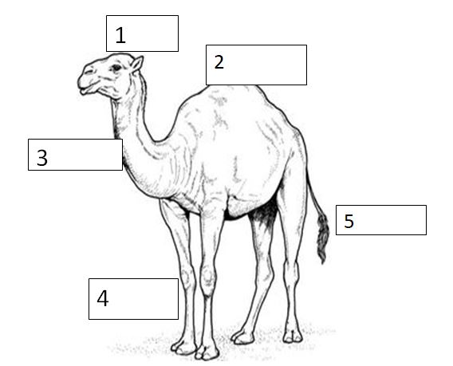
1
3
4

Essay type question
Q.1 Write five sentences using the clues given in the brackets. (Each sentence carries two marks.) (10)
(long beak, funny bird, no wings, short legs, no tail)
The Kiwi:
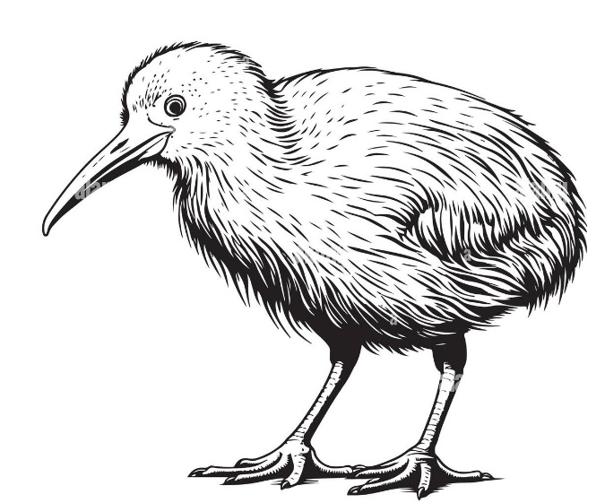
- The kiwi has ______________________.
- _________________________________.
- _________________________________.
- _________________________________.
- _________________________________.

