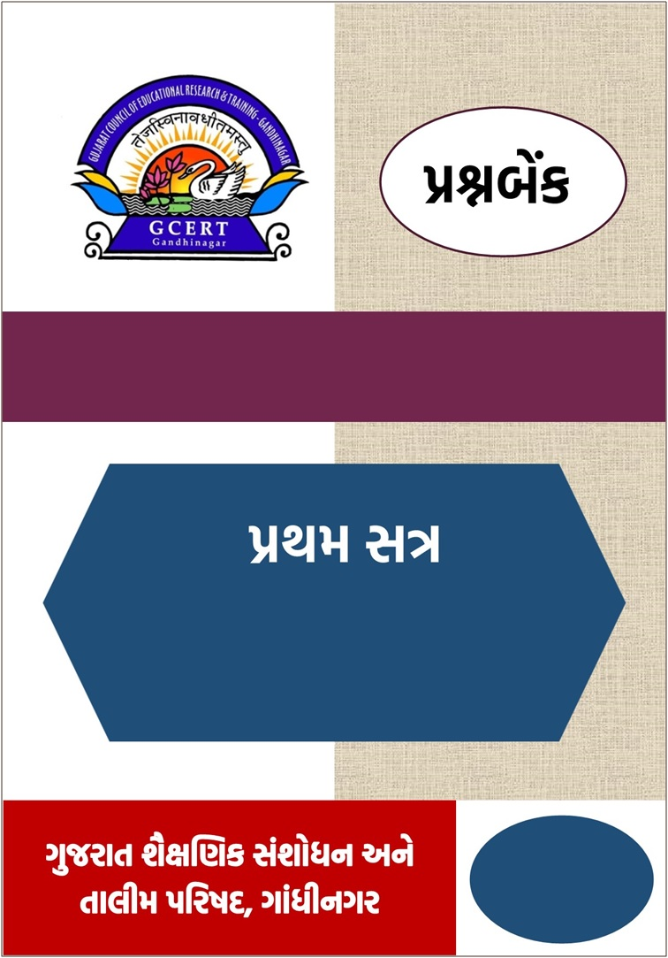

**વિષય –**  અંગ્રેજી

**પ્રકરણ: 1, 2**

**વર્ષ : 2025-26**

**ધોરણ – 5**

|  |  |  |  |
| --- | --- | --- | --- |
| **ધોરણ 5 (અંગ્રેજી) પ્રથમસત્ર પ્રકરણ (1,2) માં સમાવિષ્ટ Learning Outcomes ની યાદી** | | | |
| **ક્રમ** | **LOs** | **વિધાન** | **પેજ નં.** |
| 1 | **E504** | **મુદ્દાને આધારે ચિત્રનું મૌખિક/લેખિત વર્ણન કરે છે અથવા ચિત્રને આધારે આપેલા શબ્દોનો ઉપયોગ કરી મૌખિક લેખિત વર્ણન કરે છે સાંભળેલી વિગતોને આધારે ચિત્ર દોરે છે.** | **3** |
| 2 | **E505** | **લોનવર્ડ સહિત આશરે (500) જેટલા શબ્દો જાણે છે વાચનમાં રહેલા તે શબ્દો ઓળખે છે અને લેખનમાં તેનો ઉપયોગ કરે છે.** | **10** |
| 3 | **E506.1** | **પ્રાસવાળા શબ્દો વાંચીને ઓળખે છે, તેની જોડ બનાવે છે, તેમાં બીજા નવા શબ્દો ઉમેરે છે અને લખે છે.** | **16** |
| 4 | **E508** | **ટૂંકી પરિચિત વાર્તા, પ્રસંગ, ઘટના સાંભળી પૂછેલી વિગતો / પ્રશ્નોના જવાબ આપે છે.** | **19** |
| 5 | **E510** | **યોગ્ય વિકલ્પો વડે આપેલ સંવાદ પૂર્ણ કરે છે. પરિચિત પરિસ્થિતિમાં સંવાદ કરે છે.** | **23** |
| 6 | **E517** | I: me - my - myself, we - us - our - ourselves, you - you - your - yourself – yourselves, he - him - his – himself, she - her - her – herself, it - it - its - itself, they - them - their - themselves જેવા સર્વનામોનો ઉપયોગ કરે છે. | **28** |

**વિષય: વિજ્ઞાન**

**C- 3.1 સમજણ અને અનુભવો વ્યક્ત કરવા માટે ફકરો લખે છે.**

**E504: મુદ્દાને આધારે ચિત્રનું મૌખિક/લેખિત વર્ણન કરે છે અથવા ચિત્રને આધારે આપેલા શબ્દોનો ઉપયોગ કરી મૌખિક લેખિત વર્ણન કરે છે સાંભળેલી વિગતોને આધારે ચિત્ર દોરે છે.**

**Objective type questions**

**Q.1 Choose the most appropriate option. (Each question carries one mark.) (15)**

### D:\Question BANK Std 6 TO 8\images\bag.jpg**1.** ____________ two bags.

1. There is B. There are
2. 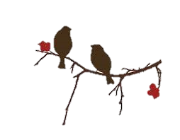Is there D. Are there

### **2.** ______________ birds on the branch? (HOT)

1. 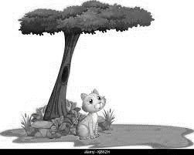Are there B. Is there
2. There are D. There is

### **3.** ______________ a cat under the tree.

1. There is B. There are
2. 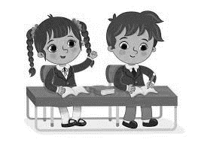Is there D. Are there

### **4.** There are _________ on the bench.

1. A boy and a girl B. a girl
2. A boy D. all of these

### D:\Question BANK Std 6 TO 8\images\bat ball.jpg**5.** There is _______ in the picture.

1. a bat B. a ball
2. a bat and a ball D. all of these

**Observe the following picture and select the correct option:**

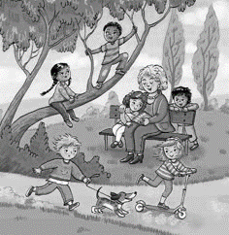

### **1.** How many ____________ are there in the garden?

1. Trees B. tree C. boy D. dog

### **2.** Is there a dog in the garden? (HOT) ___________________________

1. Yes, there are. B. No, there isn’t.
2. Yes, there is. D. No, there aren’t.

### **3.** There is ________ behind the bench.

1. a boy B. a pig C. a dog D. a woman

### **4.** _____________ children on the tree? (HOT)

1. Is there B. Are there C. There is D. There are

### **5.** This is a picture of a _________

1. garden B. hospital C. school D. fair

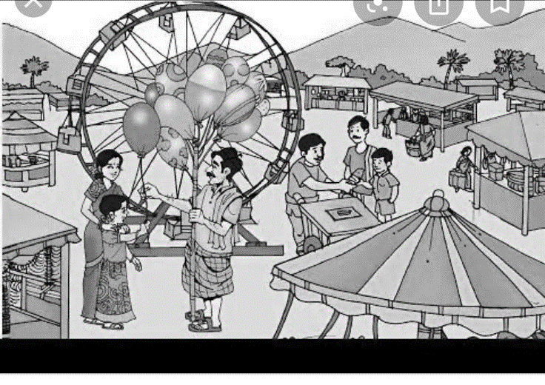**Observe the following picture and select the correct option:**

### **1.** This is a picture of a __________

1. fun fair B. play-ground C. garden D. school

### **2. ____________ many stalls in the fair.**

### **A. There is B. There are C. There are D. B and C**

### 3. There is an/a__________ in the picture. (HOT)

1. Ice-cream vendor B. Balloon-man C. Shopkeeper D.All of the above

### Are there balloons in the fair? __________________________

### Yes, there is. B. No, there isn’t. C. Yes, there are D. No, there aren’t.

### There is ___ ice-cream vendor in the fun fair.

1. a B. an C. the D. none

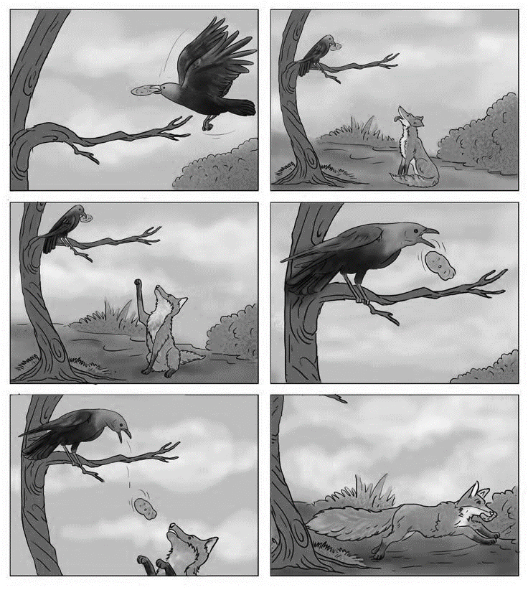**Q.2 Observe the picture-story.**

**Read the sentences and write ‘True’ or ‘False’. (HOT) (Each question carries one mark.) (05)**

1. There is a bird in the picture.
2. The fox had a puri in his beak.
3. The fox wanted the puri.
4. The crow was cunning.
5. The crow started singing. So the puri fell down.

**Q.3 Match the correct picture with the correct word: (Each question carries one mark.) (05)**

|  |  |  |
| --- | --- | --- |
| **A** | **B** | **Answer** |
| 1. **A bench** | D:\Question BANK Std 6 TO 8\images\a ball.png**A)** | **1. ___** |
| 1. **A ball** | D:\Question BANK Std 6 TO 8\images\books.jpg**B)** | **2. ___** |
| 1. **Balls** | D:\Question BANK Std 6 TO 8\images\bench.jpg**C)** | **3. ___** |
| 1. **A book** | **D)** | **4. ___** |
| 1. **books** | D:\Question BANK Std 6 TO 8\images\book.jpg**E)** | **5. ___** |

**Very short answer questions**

**Q.1 Observe the picture. Fill in the blanks using the words given in the bracket. (Each question carries one mark.) (05)**

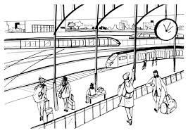

1. _____________________ passengers on the platform. (There are, There is)
2. There is a passenger _________ the bench. (under, on)
3. There _______ a clock hanging in the platform. (is, are)
4. There is a cow on the railway station. true or false?
5. How many trains are there in the picture? ________

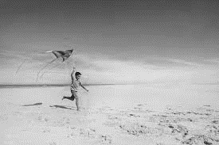**Q. 2 Observe the picture. Fill in the blanks using the words given in the bracket. (Each question carries one mark.) (05)**

(a kite, a boy, afternoon, beach, sunny)

1. There is _________ in the picture.
2. He is flying __________.
3. He is on the __________.
4. It’s a _________ day.
5. It’s __________ time. (HOT)

**Short answer questions**

**Q.1 Observe the picture and complete the sentences. (Each question carries one mark.) (05)**

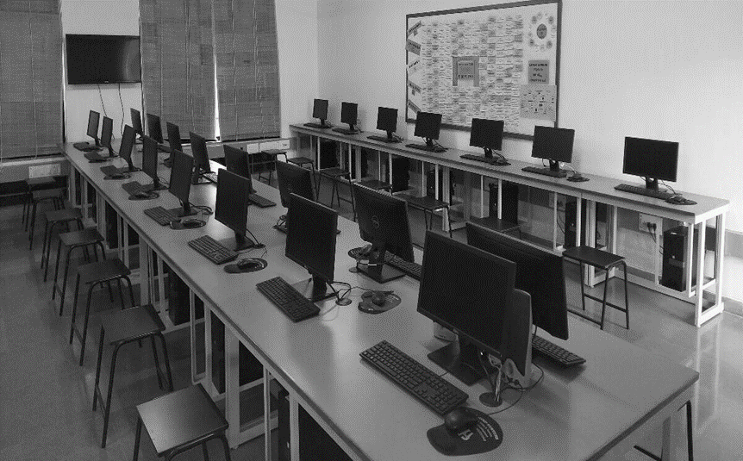

1. This is a picture of a _________________. (laboratory/computer lab)
2. There are ___ rows of computer. (two/three)
3. There is a flat TV_____ the wall. (near/on)
4. There ____ no students in the lab. (is/are)
5. There are ________ in the lab. (chairs/stools)

**Q.2 Observe the picture and answer the questions. (Each question carries two marks.) (10)**

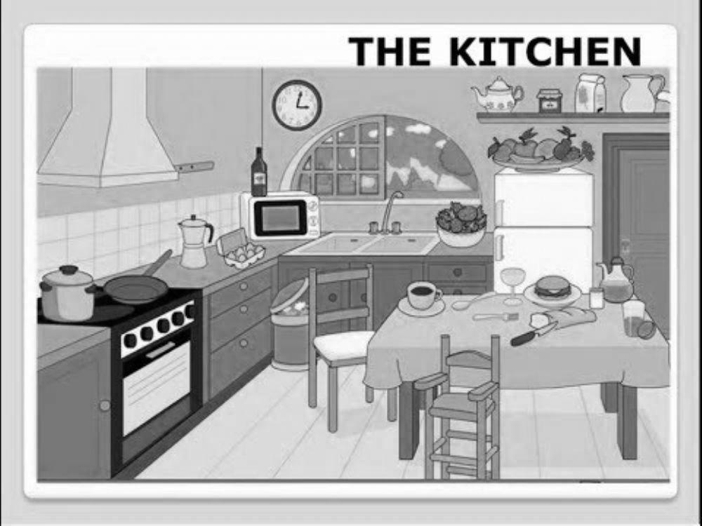

1. How many chairs are there in the picture?
2. What is this picture of?
3. Where is the clock?
4. How many windows are there in the kitchen?
5. Where is the fruit basket?

**Essay type questions**

**Q.1 Study the picture and make sentences. Clues are given in the brackets. (Each sentence carries one marks.) (05)**

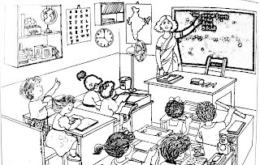

(a board, a table, a clock, students, a map)

**___________________________________________________**

**___________________________________________________**

**___________________________________________________**

**___________________________________________________**

**___________________________________________________**

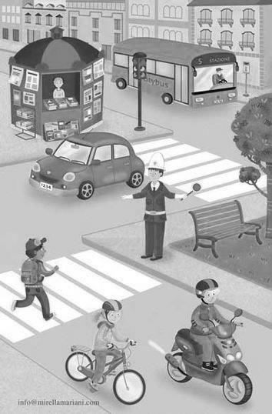**Q.2 Study the picture and make sentences. Clues are given in the brackets. (Each sentence carries one marks.) (5)**

**(a book store, a traffic police, a bench, a traffic signal, vehicles)**

**___________________________________________________**

**___________________________________________________**

**___________________________________________________**

**___________________________________________________**

**___________________________________________________**

**C 4.1 બીજા અભ્યાસ ક્ષેત્રોની મુદ્રિત સામગ્રી સાંભળીને અને વાંચીને શબ્દોના અર્થોની ચર્ચા કરે છે અને શબ્દો ભંડોળનો વિકાસ (અભિવ્યક્તિ મારફતે) દર્શાવે છે**

**E505: લોનવર્ડ સહિત આશરે (500) જેટલા શબ્દો જાણે છે વાચનમાં રહેલા તે શબ્દો ઓળખે છે અને લેખનમાં તેનો ઉપયોગ કરે છે.**

**Objective type questions**

**Q.1 Choose the most appropriate option. (Each question carries one mark.) (15)**

(1) According to you ‘trio’ means…

A.    A group of three people/things B.    A name of a person

C.   A name of a place D.   A trip

(2) The correct alphabetical order is?

A.    Alien, magical, forest, adventure B.    Adventure, alien, forest, magical

C.   Alien, adventure, forest, magical D.   adventure, alien, magical, forest

(3) _______ is not a rhyming word of ‘cat’.

A.   hat B.   tat C.   bed D.   rat

(4) What is the similar word of unhappy?

A.   joyful B.   love C.   weak D.   sad

(5) What is opposite word for ‘coward’? (HOT)

A.   brave B.   timid C.   weak D.   fearful

(6) Find out the opposite word for ‘strange’

A.   normal B.   uncommon C.   unusual D.   All of the above

(7) It is a colour of buffalo. It is a colour of my hair. What colour am I?

 A.  yellow B.   pink C.   white D.  black

(8) Find out the correct word (HOT)

A.   firebone B.   bonefire C.   bonfire D.   bornfire

(9) Find out the correct spelling

A.  Straight B.  Staright C.  Strit D.   Strate

(10) Where can we use tents?

A.    in a forest B.    in a house C.   in a school D.   in a library

(11) ________ cannot glow.

A.    star B.    bulb C.   light D.   blackboard

(12) They felt _____ and curiosity.

A.    fair B.    fare C.   fear D.   all of the above

(13) Find out the activity which is not adventurous.

A.   swimming B.   trekking C.   rafting D.   sleeping

(14) complete the word: C_R_F_L_Y

A.    L, U, E, A B.    A, E, U, L C.   U, E, I, U D.   U, A, E, I

(15) Find the odd one out

1. scissors B. band aid C. cotton D. pencil

**Q.2 Match ‘A’ with ‘B’. (HOT) (Each question carries one mark.) (05)**

**A B Answers**

1.     trip                       (a) medicine (1-_____)

2.     sick                         (b) picnic (2-_____)

3.     pill                   (c) ill (3-_____)

4.     strange                   (d) shine (4-_____)

5.     glow                    (e) unknown (5-_____)

**Q.3** **Study the pictures and write down the name of the taste from the brackets. (Each sentence carries two marks.) (05)**

(sweet, sour, bitter, spicy salty)

|  |  |
| --- | --- |
| **Food Items** | **Taste** |
| **A black and white drawing of different types of chocolate  AI-generated content may be incorrect. Chocolate** |  |
| **A black and white drawing of a vegetable  AI-generated content may be incorrect. Bitter gourd** |  |
| **A black and white drawing of a lemon  AI-generated content may be incorrect. Lemon** |  |
| **A red pepper with a green stem  AI-generated content may be incorrect. Chilly** |  |
| **A black and white illustration of a salt container  AI-generated content may be incorrect. Salt** |  |

**Very short answer questions**

**Q.1 Observe the pictures. Write their names from the brackets. (Each question carries one mark.) (05)**

(book, blackboard, duster, chalk-sticks, pencil)

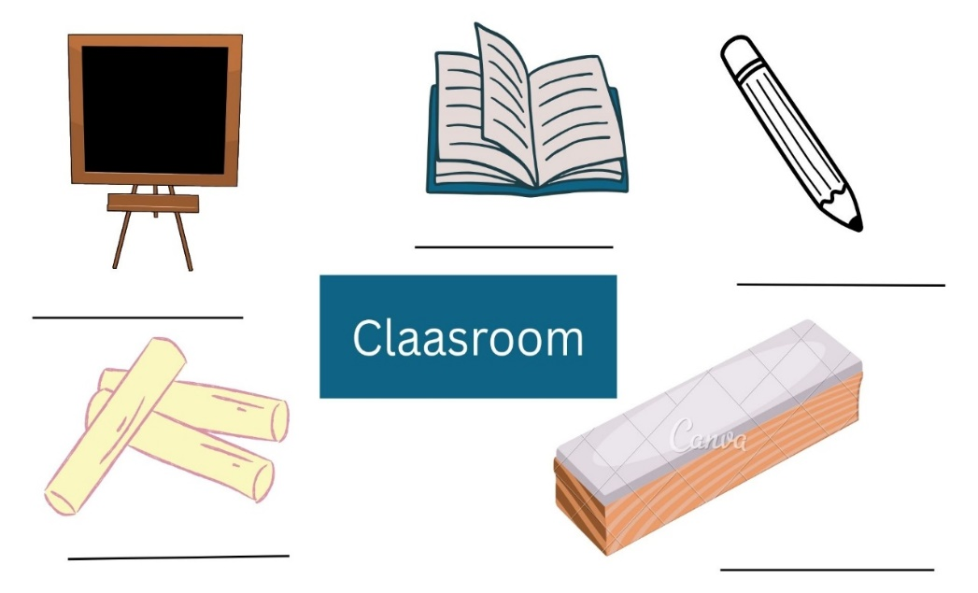

**Q.2 Read the across and down keys and solve the puzzle: (Each sentence carries one mark.) (05)**

(cousin, pill, first aid, forest, bonfire)

|  |  |  |  |  |  |  |  |  |
| --- | --- | --- | --- | --- | --- | --- | --- | --- |
|  |  |  |  |  | (1) b |  |  | (2) f |
|  |  |  |  |  |  |  |  |  |
| (1)c |  |  |  |  | n |  |  |  |
|  |  |  |  |  |  |  |  |  |
| (3)p |  |  |  |  |  |  |  |  |
|  |  |  |  |  |  |  |  | a |
|  |  | (2) f |  |  | e | s | t |  |
|  |  |  |  |  |  |  |  | d |

**Across:**

1. Your uncle’s daughter /son is your__________.
2. Similar word for jungle =__________.

**Down:**

1. Fire around which you can sing and dance during night.
2. A kit used for medical emergency.
3. We must take this when we are ill.

**Short answer questions**

**Q.1 Answer the questions using the words given in the brackets. (Each sentence carries two marks.) (05)**

(excited, calm, sad, crying, worried)

1. How do you feel when you fell down?
2. How do you feel when you lose your favourite toy?
3. How do you feel when your birthday is near?
4. How do you feel when you forget your homework?
5. How do you feel when you sleep in your mother’s lap?

**Q.2 Arrange the following words in the alphabetical order. (Each sentence carries two marks.) (05)**

1. fun, game, help, friends
2. down, cheerful, sad, answer
3. cheeks, red, ask, look
4. cry, little, family, puppy
5. green, rubber, four, teeth

**Essay type questions**

**Q.1 Study the following word web and write five sentences on ‘My farm’. (Each sentence carries two marks.) (10)**

My farm:

This is my farm.

There is/are________________.

**___________________________________________________**

**___________________________________________________**

**___________________________________________________**

**___________________________________________________**

**___________________________________________________**

**Q.2 Write a paragraph on “Our First Aid Box’ using the following words. (Each sentence carries two marks.) (10)**

(a pair of scissors, a bandage roll, antiseptic liquid, ointment, cotton)

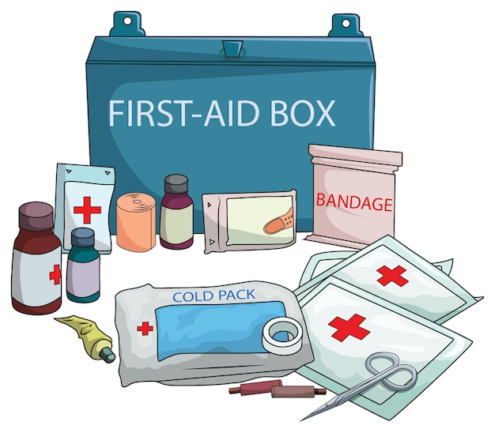

Our First Aid Box:

This is our first aid box.

There is/are _______________.

**___________________________________________________**

**___________________________________________________**

**___________________________________________________**

**___________________________________________________**

**___________________________________________________**

**C- 2.1 ધ્વનિને શબ્દોમાં મિશ્રિત કરીને અને શબ્દોને ધ્વનિમાં વિભાજિત કરીને ધ્વનિ જાગૃતિનો વિકાસ પ્રદર્શિત કરે છે.**

**E506.1: પ્રાસવાળા શબ્દો વાંચીને ઓળખે છે, તેની જોડ બનાવે છે, તેમાં બીજા નવા શબ્દો ઉમેરે છે અને લખે છે.**

**Objective type questions**

**Q.1 Choose the most appropriate options. (Each question carries one mark.) (15)**

1. ________ rhymes with 'fun'?  
   (A) gun (B) bun (C) sun (D) All of these
2. ________ does not rhyme with 'hat'?  
   (A) cat (B) bat (C) mat (D) hot
3. Select the rhyming pair:  
   (A) dog – dig (B) sun – run (C) pen – pan (D) cap – cup
4. Find the odd one out (not rhyming with others): (HOT)  
   (A) light (B) kite (C) bite (D) book
5. What rhymes with 'go'?  
   (A) so (B) to (C) two (D) all of these
6. Select the correct group of rhyming words. (HOT)  
   (A) pin – pen –ten (B) cap – map – tap  
   (C) bed – bad – bat (D) ball – bell – bell
7. 'Cake' rhymes with ‘_______’.  
   (A) take (B) make (C) bake (D) all of these
8. Choose the word that rhymes with 'chair':  
   (A) fair (B) cheer (C) chat (D) bear
9. 'The cat sat on the ___.' What is the rhyming word for the words underline? (HOT)  
   (A) mat (B) cup (C) fan (D) pan
10. Match the rhyming word with 'hill':  
    (A) sell (B) well (C) fill (D) tall
11. ‘_______’ does not rhyme with 'cold'?  
    (A) sold (B) told (C) gold (D) warm
12. Select the correct rhyming pair. (HOT)  
    (A) 'cap' – 'map' (B) 'dog' – 'log' (C) 'knee' – 'bee' (D) all of these
13. What rhymes with 'look'?  
    (A) cook (B) rock (C) black (D) kick
14. Choose the word that rhymes with 'train':  
    (A) rain (B) ran (C) pin (D) tin
15. Which line has rhyming words?  
    (A) The boy is tall, he has a ball. (B) I like to play and eat.  
    (C) She runs fast and jumps. (D) The sky is blue and big.

**Q.2 Match ‘A’ with ‘B’ and make rhyming pairs. (HOT) (Each sentence carries one mark.) (05)**

|  |  |  |
| --- | --- | --- |
| **A** | **B** | **Answer** |
| 1. one | a. tower | 1.___ |
| 1. more | b. fun | 2.___ |
| 1. see | c. visit | 3.___ |
| 1. digit | d. key | 4.___ |
| 1. hour | e. four | 5.___ |

**Q.3 Fill in the blanks with the most appropriate rhyming words of underlined words.**

**(HOT) (Each sentence carries one mark.) (05)**

(light, wall, log, fun, Jet)

1. I have a pet. His name is ___.  
2. The dog sat on a ___.

3. I like to run and have some ___.

4. The sun is bright. It gives us ___.

5. The boy threw the ball against the ___.

**Very short answer questions**

**Q.1 Answer in one word on your own. (HOT) (Each sentence carries one mark.) (05)**

1. Write any one word that rhymes with ‘tree’: ___________
2. Add a rhyming word to this list: king, ring, _______
3. Continue the rhyming pattern: log, fog, _______
4. Write a rhyming word for cake: __________
5. Complete the sentence with a rhyming word of underlined word:  
   The fox sat on the __________.

**Q.2 Read the passage and write five rhyming pairs. (Each sentence carries one mark.) (05)**

Mina has a little **dog**. It likes to jump in the **fog**. One day, the dog saw a **cat** sitting on a red **mat**. The cat ran fast to chase a **mouse** that was near the **house**. Mina wore a big blue **hat** and held a wooden **bat**. She saw the sun shine on the green **tree** and smiled with so much **glee**. After playing, she sat on a **chair** and brushed her long brown **hair**.

1. __________ - __________
2. __________ - __________
3. __________ - __________
4. __________ - __________
5. __________ - __________

**Short answer questions**

**Q.1 Read the poem and answer the question. (HOT) (Each question carries two marks.) (10)**

One fine day, Sam took a long **walk.**  
He saw a man begin to **talk**  
to a bird that sat on a **tree,**  
singing a song full of joy and **glee.**  
The sun was high, the sky was **blue,**  
and flowers danced with drops of **dew.**  
Sam found a bench and took a **rest,**  
feeling calm, happy, and truly **blessed.**

1. Which word rhymes with ‘**walk’**?
2. Find a rhyming word for ‘**tree’**.
3. What rhymes with ‘**blue’**?
4. What is the rhyming word for ‘**test’**?
5. Find out one word that rhymes with **‘bun’**.

**C- 2.4 વાર્તાઓ, કવિતાઓ અને વાર્તા પોસ્ટરોનું અર્થગ્રહણ કરે છે.**

**E508 ટૂંકી પરિચિત વાર્તા, પ્રસંગ, ઘટના સાંભળી પૂછેલી વિગતો / પ્રશ્નોના જવાબ આપે છે.**

**Objective type questions**

**Q.1 Read the story and choose the most appropriate options. (Each question carries one mark.)(15)**

**Mina and the Lost Pencil**

Mina is a little girl. She goes to school every day. One day, she cannot find her pencil. She looks under her bag. She looks in her desk. The pencil is not there.

Mina asks her friend Rahul, “Have you seen my pencil?” Rahul says, “No, I have not.”  
Then, Mina goes to the teacher. The teacher smiles and says, “Look in the library.”  
Mina runs to the library. She sees her pencil on the floor near the bookshelf. She is happy and says, “Thank you!”

1. Who is the girl in the story?  
   (A) Rina (B) Mina (C) Neha (D) Ritu
2. What did Mina lose?  
   (A) book (B) pencil (C) eraser (D) bag
3. Where did Mina look first?  
   (A) under the bag (B) library (C) teacher’s table (D) Rahul’s bag
4. Mina asked ______ for help.  
   (A) Rina (B) Rahul (C) the librarian (D) her mother
5. Rahul said, “________.”  
   (A) Yes, I have it (B) No, I have not (C) Give me your pencil (D) I am busy
6. Where did the teacher tell Mina to go?  
   (A) home (B) Rahul’s class (C) library (D) playground
7. Where was the pencil?  
   (A) on the teacher’s table (B) inside her bag  
   (C) on the floor near bookshelf (D) in her hand
8. Mina felt _______ at the end.  
   (A) sad (B) happy (C) tired (D) angry
9. What did Mina say at the end?  
   (A) Sorry (B) No (C) Thank you (D) It’s mine
10. What is the story about?  
    (A) a girl and a book (B) a lost bag  
    (C) a boy and his toy (D) a pencil lost and found
11. Who is Mina’s friend in the story?  
    (A) Ravi (B) Riya (C) Rahul (D) Reena
12. What is the opposite of ‘**lost’**? (HOT)  
    (A) keep (B) give (C) find (D) found
13. After talking with Rahul, ________. (HOT)  
    (A) She finds the pencil (B) She eats lunch  
    (C) She goes to the teacher (D) She cries
14. Choose the rhyming word for ‘**floor’.** (HOT)  
    (A) more (B) fall (C) book (D) gate
15. Choose the correct spelling:  
    (A) pencel (B) pansil (C) pencil (D) pensil

**Q.2 Read the passage and do as directed.**

The lion is a wild animal. It lives in the jungle. It has a loud roar and sharp teeth. Lions eat meat. They live in groups called ‘prides’.

1. **Fill in the blanks. (Each question carries one mark.) (05)**

(teeth; wild; prides; meat; jungle)

1. The lion is a __________ animal.
2. Lions live in the __________.
3. A lion has sharp __________.
4. Lion eats __________.
5. Lions live in groups called __________.
6. **Write ‘True’ or ‘False’. (HOT) (Each question carries one mark.) (05)**
7. Lion is a small pet. __________
8. Lion make a loud roar. __________
9. Lions eats fruit and vegetables. __________
10. Lion lives in a jungle. __________
11. A group of lions is called army. __________

**Very short answer questions**

**Q.1 Read the passage and complete the sentences. (Each question carries one mark.) (05)**

One day, Rehan saw a puppy stuck in a bush. The puppy was crying. Rehan gently took it out and gave it water. He waited until the puppy felt better. Rehan was kind and caring.

* 1. Rehan saw a puppy __________.
  2. The puppy was __________.
  3. Rehan gave the puppy __________.
  4. He waited until the puppy __________.
  5. Rehan was __________ and __________.

**Q.2 Read the passage and answer the questions. (Each question carries one mark.) (05)**

Aman went to the zoo with his parents. He saw three lions, two elephants, and five monkeys. There were also four peacocks dancing in the garden. Aman was very happy to see all the animals.

* 1. How many lions are there?
  2. How many elephants are there?
  3. How many monkeys are there?
  4. How many peacocks are there?
  5. How many animals are there in total?

**Short answer questions**

**Q.1 Read the passage and answer the questions. (Each question carries one mark.) (05)**

Ziya went to the market with her mother. She saw many fruits and vegetables. Her mother bought apples, bananas, and carrots. Ziya helped her to carry the bag. They came home and made fruit salad together.

1. Ziya went to the __________ with her mother.
2. Ziya saw many fruits and vegetables. True or false?
3. Her mother bought apples, ___________ and carrots.
4. Ziya helped her mother to ___________.
5. How many fruits did her mother buy?

**Q.2 Read the passage and write names. (Each question carries one mark.) (05)**

|  |  |
| --- | --- |
| **Parrot:** The parrot is a green bird. It has a red beak. It lives in trees. The parrot can talk. It eats fruits and seeds | **Crow:** The crow is a black bird. It is very clever. It lives on trees and buildings. The crow makes a loud sound. It eats food from the ground. |

* 1. I am green in color. I have a red beak. I can talk. Who am I? __________
  2. I am black. I am clever. I eat food from the ground. Who am I? __________
  3. I live in trees. I eat fruits and seeds. Who am I? __________
  4. I live on trees and buildings. I make a loud sound. Who am I? __________
  5. I am a bird with a red beak. I can say a few words. Who am I? __________

**Essay type questions**

**Q.1 Separate the sentences of Diwali and Uttarayan, and write them. (Each sentence carries one mark) (10)**

Uttarayan is the festival of kites. Diwali is the festival of lights. People clean and decorate their homes with rangoli. People fly colourful kites in the sky. They light diyas and candles. Families wear new clothes and eat sweets. The wind helps the kites fly high. Children enjoy bursting crackers during Diwali. Everyone shouts “Kai Po Chhe!” while flying kites. Uttarayan is celebrated in January with joy.

|  |  |
| --- | --- |
| **Diwali** | **Uttarayan** |
|  |  |
|  |  |
|  |  |
|  |  |
|  |  |

**C-1.3: અર્થપૂર્ણ અને સુસંગત રીતે વાતચીત કરે છે.**

**E510: યોગ્ય વિકલ્પો વડે આપેલ સંવાદ પૂર્ણ કરે છે. પરિચિત પરિસ્થિતિમાં સંવાદ કરે છે.**

**Objective type questions**

**Q.1 Choose the most appropriate options.** **(Each question carries one mark.) (15)**

1. Ramesh: What is your name?  
Priya: ___________  
(A) I am ten. (B) I like apples. (C) My name is Priya. (D) I am fine.

2. Asha: How are you?  
Rehan: ___________  
(A) I am fine, thank you. (B) My name is Rehan.   
(C) I am going to school. (D) I have two books.

3. Neha: Where do you live?  
Amit: ___________  
(A) I am eight years old. (B) I live in Surat.  
(C) I like mangoes. (D) I can run.

4. Mohan: What is it?  
Kiran: ___________  
(A) It is a ball. (B) I am playing.  
(C) I have five. (D) No, I don’t.

5. Meena: What do you like to eat?  
Rohit: ___________  
(A) I like to eat bananas (B) I go to school.  
(C) I play with toys. (D) I have a pencil.

6. Reena: What is the name is your best friend? (HOT)  
Anil: ___________  
(A) I like milk. (B) His name is Rahul.  
(C) I have a bag. (D) I am six.

7. Leela: Can you swim?  
Soham: ___________  
(A) I go to market. (B) Yes, I can.  
(C) I eat rice. (D) I have two pens.

8. Vikas: What are you doing?  
Sneha: ___________  
(A) I have a red pen. (B) I am seven.  
(C) I am reading a book. (D) My name is Sneha.

9. Ajay: Is this your pencil?  
Pooja: ___________  
(A) I like dogs. (B) I have three.  
(C) I am dancing. (D) Yes, it is.

10. Rina: When do you play? (HOT)  
Arun: ___________  
(A) I play football. (B) I play in the evening.   
(C) I have two bats. (D) I go to school.

11. Divya: Do you have a pet?  
Manav: ___________  
(A) I run fast. (B) I am in class four.  
(C) Yes, I have a dog. (D) I go to market.

12. Tina: What is your favourite colour?  
Nikhil: ___________  
(A) My favourite colour is blue. (B) I like to run.  
(C) I am eating. (D) I live in Surat.

13. Rahul: Where is your school?  
Simran: ___________  
(A) I go every day. (B) I am eight.  
(C) It is near the park (D) I love sweets.

14. Falguni: Do you like to sing?  
Kabir: ___________  
(A) Yes, I like to sing. (B) I like to dance.  
(C) I eat mango. (D) My book is red.

15. Nisha: What do you do on Sundays? (HOT)  
Varun: ___________  
(A) I go to class. (B) I write with pen.  
(C) I eat fruit. (D) I play with my friends.

**Q.2 Match and complete the dialogue between Ziya and Riya. (HOT) (Each question carries one mark.) (05)**

|  |  |  |
| --- | --- | --- |
| **Ziya** | **Riya** | **Answer** |
| 1. What are you doing? | (A) They sleep at 10 p.m. | 1. ___ |
| 2. When do they sleep? | (B) My brother is in class 7. | 2. ___ |
| 3. Who is in class 7? | (C) I am reading a book. | 3. ___ |
| 4. What is this? | (D) My hobby is swimming. | 4. ___ |
| 5. What is your hobby? | (E) It is a pencil. | 5. ___ |

**Q.3 Read the dialogue and write ‘True’ or ‘False.’ (Each question carries one mark.) (05)**

Rehan: Hello, what is your name?  
Falguni: My name is Falguni.  
Rehan: How are you today?  
Falguni: I am fine, thank you.  
Rehan: Do you like to play football?  
Falguni: Yes, I love football.  
Rehan: When do you play?  
Falguni: I play in the evening with my friends.

1. Rehan and Tina are talking here.
2. Rehan is feeling well. (HOT)
3. Falguni loves to play football.
4. Falguni plays in the morning.
5. Rehan asked ‘When do you go to school?’

**Very short answer questions**

**Q.1 Answer in one word. (Each question carries one mark.) (05)**

(yes; birds; Wednesday; no; two)

1. What comes after one? __________
2. What can fly? __________
3. What comes after Tuesday? __________
4. Do you come to school on Sunday? __________
5. Can you read English? __________

**Q.2 Complete the dialogues using the most appropriate options from the brackets. (Each question carries one mark.) (05)**

1. **Priya** : What is your name?  
   **Anjali** : _____ name is Anjali. (his, my)
2. **Arun** : Hello, Rita! How _____ you? (are, am)  
   **Rita** : I am fine.
3. **Ravi** : Where do you live?  
   **Kiran** : I _____ in Delhi. (live, is)
4. **Neha** : How are you, Zishan?  
   **Zishan** : I am _____. (fine, name)
5. **Nisha** : _____ is this? (What, That)  
   **Rohit** : This is a book.

**Short answer questions**

**Q.1 Give the numbers in a proper order to the dialogues and rewrite. (HOT) (Each question carries one mark.) (05)**

_____ (a) Hello, what is your name?

_____ (b) My name is Meena.

_____ (c) Hello!

_____ (d) Nice to meet you.

_____ (e) Nice to meet you too.

**Q.2 Read the dialogue and do as directed. (HOT) (Each question carries one mark.) (05)**

Pooja : Hello Karan!  
Karan : Hello Pooja. How are you?  
Pooja : I’m fine. What about you?  
Karan : I’m good. Where are you going?  
Pooja : I’m going to the market.

1. Where is Pooja going?  
   (A) school (B) market (C) home (D) park
2. **Fill in the blank.**  
   Pooja says, "Hello _______!"
3. **Fill in the Blank.**  
   Karan says, "Where are you _______?"
4. Karan says, "I’m going to the market." – True or False (HOT)
5. Pooja and Karan greet each other. – True or False (HOT)

**Essay type questions**

**Q.1 Complete the dialogues using the most appropriate options given in the brackets. (HOT) (10) (Each question carries two marks.)**

(How are you; Hello, Neha; See you soon; thank you. And you; I’m going to school)

Rahul : ____________.  
Neha : Hello, Rahul.  
Rahul : _______________ ?  
Neha : I am fine, ____________?  
Rahul : I am fine too.  
Neha : Where are you going?  
Rahul : _________________________.  
Neha : Alright. ________________!

**C- 2.2: મુદ્રિત સામગ્રીમાંથી લખાણના મૂળભૂત માળખાને સમજીને શબ્દો, વાક્યો અને વિરામચિહ્નની ઓળખ રજૂ કરે છે.**

**E517.1:** me - my - myself, we - us - our - ourselves, you - you - your - yourself – yourselves, he - him - his – himself, she - her - her – herself, it - it - its - itself, they - them - their - themselves જેવા સર્વનામોનો ઉપયોગ કરે છે.

**Objective type questions**

**Q.1 Choose the most appropriate options.** **(Each question carries one mark.) (15)**

1. _____ am going to the market.
2. Me B. Myself C. I D. Us
3. This is _____ book.
4. Me B. My C. Mine D. I
5. We cooked the food by _____. (HOT)
6. Our B. Ourselves C. Us D. Myself
7. She hurt ____ while running. (HOT)
8. Her B. hers C. herself D. she
9. He gave the ball to _____.
10. Himself B. me C. my D. I
11. That cat is licking ____ paw.
12. Her B. his C. its D. their
13. They went to the zoo by _____.
14. Their B. themselves C. them D. ourselves
15. She is helping _____ brother with homework.
16. Her B. she C. hers D. herself
17. This gift is for ____ and my friend.
18. Me B. I C. myself D. mine
19. You must do your homework by _____.
20. Yourselves B. us C. yourself D. themselves
21. The dress is very attractive. I like_____ very much.
22. It B. them C. they D. me
23. This is not your bag. It is ___. (HOT)
24. Your B. you C. mine D. me
25. We enjoyed ___ at the picnic.
26. Us B. we C. ourselves D. our
27. He looked ___ in the mirror.
28. Him B. himself C. he D. his
29. My brother and I made this model. ___ did it together. (HOT)
30. Us B. our C. we D. ourselves

**Q.2 Read at the underlined words and write True or False: (Each question carries one mark.) (05)**

1. I brushed teeth herself in the morning.
2. We enjoyed ourselves at the fair.
3. You should do your homework by yourself.
4. Myself went to the market
5. Us are going to the zoo today.

**Q.3 Match ‘A’ with ‘B’. (Each question carries one mark.) (05)**

|  |  |  |  |  |
| --- | --- | --- | --- | --- |
|  | **A** |  | **B** | **Answers** |
| 1 | I wrote this story by ___. | a | himself | 1.___ |
| 2 | She helped __ with her homework. | b | myself | 2.___ |
| 3 | He made the model by ___ | c | us | 3.___ |
| 4 | Our teacher gave ___ stars. | d | her | 4.___ |
| 5 | Rani gave ___ lunch box. | e | me | 5.___ |

**Very short answer questions**

**Q.1 Fill in the blanks using the words given in the brackets. (Each question carries one mark.) (05)**

(me, them, themselves, their, They)

Mishty and Prisha are friends. _________ go to school together. They always respect _________ teachers. They do their homework ________. When I play with _______, I always enjoy. They also enjoy playing with _____.

**Q.2 Correct the underlined parts using the words given in the brackets. (Each question carries one mark.) (05)**

**(herself, him, himself, her, He)**

1. Shailesh likes chocolates. Give her some chocolates.
2. Vishal will do his work yourself.
3. Megha sings song myself.
4. Amit is a doctor. Him is very punctual.
5. Bhavna wants to do its work.

**Short answer questions**

**Q.1 Make sentences using the words given in the brackets. (Each question carries one mark.) (05) (he, she, they, it)**

|  |  |
| --- | --- |
| Example: Mehul is a doctor. | He is a doctor. |
| 1. Asha and Nisha are friends. |  |
| 1. Suresh is a policeman |  |
| 1. Rinkal is a nurse. |  |
| 1. Hetal is an engineer. |  |
| 1. An elephant is in the pond. |  |

**Q.2 Rewrite the sentences replacing the underlined parts(Each question carries one mark.) (05)**

1. Krishna is my sister. Krishna’s mother lives in Pardi.

She is my sister. ___________________________.

1. Ketan is my friend. Ketan’s shop is in Ahmedabad.

He is my friend. ____________________________.

1. Tommy is my pet dog. I shall give Tommy milk.

He is my pet dog. _________________________.

1. Sanket is my brother. I shall give Sanket an ice cream.

He is my brother. ___________________________.

1. Neeta is my student. I shall give Neeta homework.

She is my student. ________________________

**Essay type questions**

**Q.1 Do as directed. (Each question carries one marks.) (05)**

Mansi is a clever girl. I like Mansi’s nature. I always give advice to Mansi. Mansi always does her work herself. I also know Mansi’s parents. They are proud of Mansi.

Start like this: She is a clever…

__________________________________________________

__________________________________________________

__________________________________________________

__________________________________________________

__________________________________________________

**Q.2 Read the paragraph and separate Manish and Manisha’s information. (Each question carries one mark.) (5)**

Manish studies in standard 8 and Manisha studies in standard 5. He likes bird-watching. She likes reading. He goes to school in the morning. She goes to school in the afternoon. He always goes to school without home work. Teacher punishes him. She is very regular in home work and so teacher appreciates her. He got the first rank in the elocution competition. She got the first rank in poem recitation.

|  |  |
| --- | --- |
| Manish | Manisha |
|  |  |
|  |  |
|  |  |
|  |  |