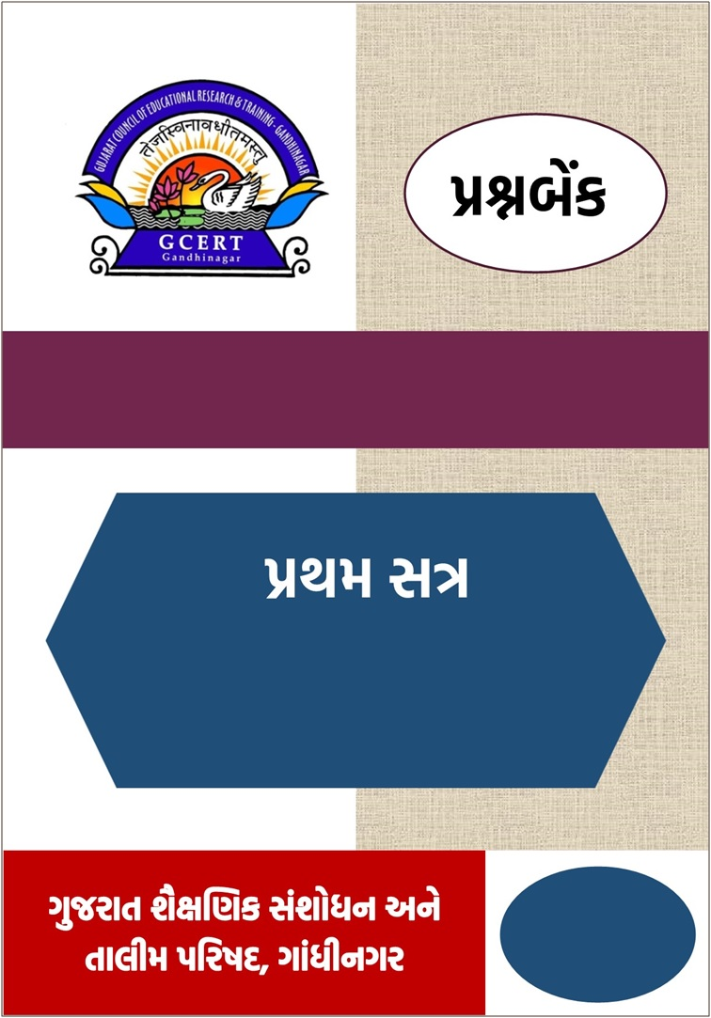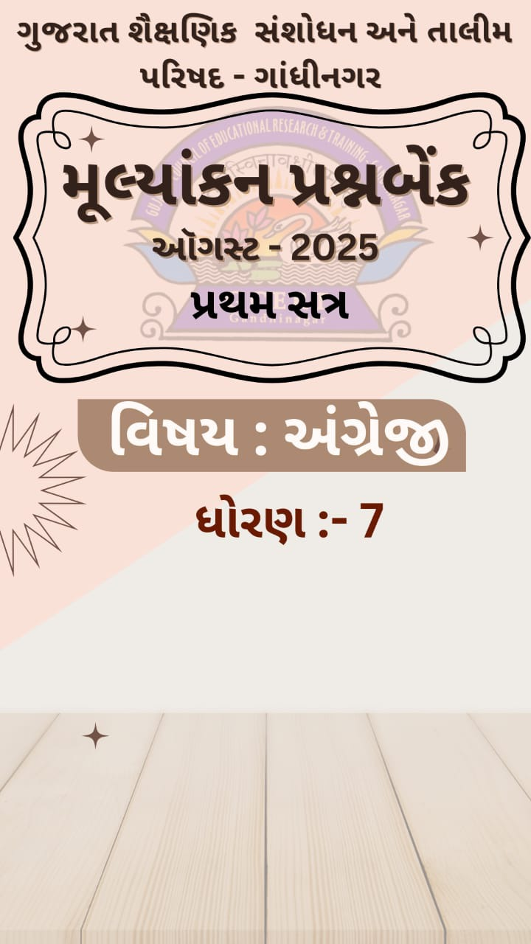

**વિષય –** અંગ્રેજી

**UNIT : 01**

**વર્ષ : 2025-26**

**ધોરણ : 7**

અધ્યયન નિષ્પતિઓ

**(Learning Outcomes)**

અંગ્રેજી ધોરણ : **07**

|  |  |  |  |
| --- | --- | --- | --- |
| **ક્રમ** | **Learning Outcomes** | **વિધાન** | **પેઇજ** |
| 1 | L.O. 705 | વાર્તા, પરિછેદ અને કાવ્યને સમજીને અર્થગ્રહણ કરે છે. | **3** |
| 2 | L.O. 710 | ચિત્રો અને પરિછેદનું વર્ગીકરણ કરે છે. | **9** |
| 3 | L.O. 713 | ઉલટ પ્રશ્નો (Inversion questions) પૂછી અને તેવા પ્રશ્નોના જવાબ આપે છે. | **17** |
| 4 | L.O. 708 | **આપેલા વિધાનોમાંથી અતાર્કિક શબ્દો તારવીને વિધાન સુધારે છે.** | **26** |
| 5 | L.O. 715 | પરિચિત પરિસ્થિતિમાં સંવાદ કરે છે. | **30** |
| 6 | L.O. 720 | વાંચન અને ઉચ્ચારનો સંબંધ તારવે છે. | **35** |



**Sub: English Std: 7 Sem. – 1 Unit :1 Vini’s Smile**

C 2.2 પોતાની આસપાસના સામાજિક અને સંસ્કૃતિક વાતાવરણના વિવિધ પાસાઓ પર પોતાના વિચારો અને વિવેચનાઓની મૌખિક અને લેખિત રજૂઆત કરે છે.

**Learning Outcome: 705 વાર્તા, પરિચ્છેદ અને કાવ્યને સમજીને અર્થગ્રહણ કરે છે.**

Objective type questions

**Q.1 Read the following rhyme and choose the appropriate option. (05)**

**Sunil's Red Balloon**

Sunil has a red balloon,

He plays with it all afternoon.

It flies up high into the sky,

He waves and shouts a big goodbye.

The wind takes it far away,

“I’ll find you again,” he starts to say.

1. What is the synonym of the word “Yells” from the poem?

A. cries B. shouts C. laughs D. whispers

2. When does Sunil play with the balloon?

A. in the morning B. at night C. all afternoon D. after dinner

3. Where does the balloon go?

A. under the tree B. into the sky C. into the box D. into the river

4. Which word in the poem means the similar of “search”? HOT

A. wind B. find C. start D. say

5. Which word in the poem means the opposite of “end”? HOT

A. fly B. start C. go D. take

**Q.2 Read the following paragraph and choose appropriate option to give answer. (05)**

The festival of Diwali is one of the most important and widely celebrated festivals in India. It is also known as the Festival of Lights. People decorate their homes with diyas, candles, and colorful rangoli. On this day, families worship Goddess Lakshmi, the goddess of wealth and prosperity. People wear new clothes, exchange sweets, and burst firecrackers to celebrate the victory of light over darkness and good over evil.

1. Which festival is known as Festival of Lights ?

A. Holi B. Diwali C.Uttarayan D.Navratri

2. Which of the following is NOT commonly done during Diwali? HOT

A. Bursting firecrackers B. Worshipping Goddess Lakshmi

C. Planting trees D. Exchanging sweets

3. Write opposite word for ‘poverty’ from the paragraph.

A. prosperity B. happiness C. celebrate D. failure

4. Write similar word for ‘success’ from the paragraph.

A. victory B. defeat C. anger D. trouble

5. What does Diwali symbolize according to the paragraph? HOT

A. The end of winter and beginning of summer

B. The festival of colors

C. The victory of light over darkness and good over evil

D. The birth of Goddess Lakshmi

**Q.3 Read the following paragraph and choose appropriate option to give answer. (05)**

One rainy afternoon, Riya was walking home from school when she heard a soft whimpering sound near the bushes. Curious, she went closer and saw a small, wet puppy shivering in the cold. Riya gently picked it up and took it home. She gave it warm milk and dried it with a towel. Riya made a small bed for it and named it Bruno. A week later, a little boy came with his father and happily recognized Bruno as his lost pet. Riya felt sad to say goodbye but she was also happy that Bruno was reunited with his real family.

1. When did Riya find the puppy? HOT

A. On a sunny morning B. During a rainy afternoon

C. On her birthday D. While playing in the park

2. What was the condition of the puppy when Riya found it?

A. Clean and playful B. Happy and energetic

C. Wet and shivering D. Sleeping peacefully

3. What did Riya do first after taking the puppy home?

A. Took it to the vet B. Gave it toys

C. Gave it warm milk and dried it D. Posted a photo online

4. Write the opposite word for ‘HOT’ mentioned in the paragraph.

A. cold B. warm C. fire D. shivered

5. How did Riya feel when Bruno left with his real family? HOT

A. Angry and upset B. Happy and proud

C. Sad but also happy D. Uninterested

**Q.4 Read the paragraph and write True or False (05)**

Navratri is a popular festival celebrated in India. It lasts for nine days and is dedicated to Goddess Amba. People wear colourful clothes and dance Garba and Dandiya during this time. Many people also keep fasts and visit temples. Navratri comes in the month of Aaso(આસો)

1. Navratri is celebrated for five days. ____
2. People worship Goddess Amba during Navratri. ____
3. Garba and Dandiya are popular dance forms of during Navratri. ____
4. Navratri is celebrated in the month of *kartak*. ____
5. People visit temples and wear traditional clothes during Navratri. ____

Q.5 Read the paragraph and match A with B. (05)

Last Sunday, we went to the zoo in our school trip. The weather was pleasant, and everyone was excited. We saw many animals like lions, elephants, monkeys, and zebras. The birds were colourful and chirping happily in their cages. We also learned about how the zoo takes care of wild animals. It was a fun and educational trip.

A B

1. Zoo a. chirping in cages

2. Lions and elephants b. excited HOT

3. Birds c. Fun and educational

4. Happy d. A place to see animals

5. School trip e. Wild animals

Very short questions

Q.1 Read the paragraph and write answer in one or two words. (05)

Rina has a cute little cat. Its name is Mimi. Mimi is white and has blue eyes. Every morning, Rina gives Mimi some milk. Then Mimi plays with a ball. In the evening, they both sit in the garden. Mimi likes to sleep in Rina’s bed. Rina loves her cat very much.

1.   What is the name of Rina’s cat?

2.   Who has blue eyes?

3.   What does Rina give Mimi every morning?

4.   Where do Rina and Mimi sit in the evening?

5.   Is Mimi a dog or a cat?

Q.2 Read the paragraph and write answer in one or two words. (05)

Arjun loved visiting his grandfather’s farm during the summer holidays. The farm was surrounded by green fields, tall mango trees, and a small pond where ducks swam. Every morning, Arjun helped his grandfather feed the cows and water the plants. In the evening, they would sit under a big banyan tree and listen to stories from his grandfather’s childhood. Arjun enjoyed the peaceful life on the farm and look forward to returning every year.

1. Where do the ducks swim?

2. Which season is mentioned in the paragraph? HOT

3. Who watered the plants?

4. Write similar word from the paragraph.

Tiny-small, Huge- ___________

1. Write the name of fruit tree mentioned in the paragraph. HOT

Q.2 Complete the paragraph with the help of the given clues. (05)

(11:00 a.m., 6:30 a.m., homework, friends, dinner, breakfast, teeth, bath, classes, play)

Every morning, I wake up at________ and brush my ________. After that, I take a quick_________ and get ready for school. My mother gives me a healthy________ before I leave. I reach school by_______ and attend all my_______. During lunch break, I sit with my_________ and enjoy my meal. After school, I come back home and do my_________. In the evening, I go out to_________ with my friends. At night, I eat_________ with my family and go to bed.

Short questions

Q.1 Read the paragraph and write answer in a sentence. (10)

Rahul was 11 years old. He loved flying kites in the park every Sunday. His grandfather had taught him how to fly them. One Sunday, Rahul was about to fly his biggest kite when he saw a little girl crying.She was lost and could not find her parents. Rahul gave her water and took her to the park’s guard. The guard made an announcement. Soon, the girl’s parents came and hugged her. They thanked Rahul.

Rahul did not fly his kite that day, but he felt happy. His grandfather said, “Helping others makes you a hero.”

1. What is the age of Rahul?

2. What did Rahul love doing every Sunday?

3. Who taught Rahul how to fly kites?

4. What did Rahul do when he saw the little girl crying?

5. Why did Rahul feel happy at the end of the story?

Q.2 Read the paragraph and write answer in a sentence. (10)

Meera was a cheerful girl living in a village. She was always kind and helpful to everyone. Every morning, she helped her mother in the garden before going to school. Meera loved learning and was very curious in class. Her favorite subject was science because she enjoyed doing fun experiments. One day, her teacher praised her for her neat work and bright ideas. Though Meera was shy, she always tried her best and never gave up. Her hardworking nature and humble attitude made her popular among her classmates.

1. What did Meera do every morning before school?
2. Why did Meera like science? HOT
3. What kind of nature did Meera have? HOT

4. Where did Meera live?

5. Find a similar word for happy from the paragraph.

Essay type questions

Q. 1 Write a short paragraph about your daily routine with the help of given questions. (10)

1. When do you wake up in the morning?

2. What do you do after waking up?

3. What do you eat for breakfast?

4. When do you go to school?

5. What do you do at school?

6. Do you take lunch in school MDM?

7. Which games do you play in the school?

8. When do you come back home from school?

9. What do you do in the evening?

10. When do you go to sleep?

Q.2 Write about Navratri on given clues. (10)

1.When is Navratri celebrated?

(Clue: month/season or time of the year)

2.How many days does Navratri have?

(Clue: number of days and nights)

3.Why Navratri is celebrated?

(Clue: goddess or victory of good over evil)

4.How do people celebrate Navratri?

(Clue: dance, music, fasting, decorations)

5.What special things do you like about Navratri?

(Clue: favorite activity, dress, food, or memory)

Q.3 Write about Rahul’s cycle from the given paragraph. (10)

Rahul lives in a small, peaceful village. Anita is a happy girl. He has a bright red cycle. The cycle has a sturdy steel frame, thick black tires and shiny silver spokes that glisten in the sunlight. She carries a magical bag. The seat is soft and padded with black leather. Her bag is blue and soft. It has a front basket where Rahul keeps his water bottle and tiffin box. If she is hungry, the bag gives her a sandwich. A small rear carrier allows him to give rides to his younger brother on weekends. The bag can talk to Anita. The handlebar is curved with soft rubber grips. it is not an ordinary bag. It has a shiny bell on the side rings with a cheerful *trring-trring*.

C 2.2 પોતાની આસપાસના સામાજિક અને સંસ્કૃતિક વાતાવરણના વિવિધ પાસાઓ પર પોતાના વિચારો અને વિવેચનાઓની મૌખિક અને લેખિત રજૂઆત કરે છે.

**Learning Outcome: 710** ચિત્રો અને પરિછેદની વિગતનું વર્ગીકરણ કરે છે.

Objective Type Question

Q.1 Read the following paragraph carefully and answer the questions. (10)

Last Sunday, Neha went to the park with her family. They sat on the grass and ate sandwiches. Neha played with her little brother. They saw birds and took pictures. Next Sunday, Neha will visit the zoo. She will see lions, elephants, and monkeys.

1. Next Sunday, Neha ______ the zoo.
   1. visit B. visited C. will visit D. has visited
2. Last Sunday, Neha will watch a movie. (Replace the underlined words with the

correct options.)

* 1. watch B. watched C. has watch D. are watching

1. Neha went to the zoo next week.
   1. go B. will go C. had gone D. gone
2. **Which sentence talks about yesterday? (HOT)**A. She will go to school tomorrow.  
   B. She sent to the park.  
   C. I will eat an apple.  
   D. She will take a bath.
3. Choose the word that talks about yesterday:  
   A. will see B. went C. will go D. visit
4. "She will see lions, elephants, and monkeys."This sentence shows:  
   A. Past action B. Future action  
   C. Present action D. Past feeling
5. What did Neha do last Sunday?  
   A. She will go to the zoo B. She played with her brother  
   C. She eats a sandwich D. She visits the zoo
6. When will Neha go to the zoo?  
   A. Last Sunday  
   B. Yesterday  
   C. Next Sunday  
   D. Today
7. Which sentence shows yesterday?  
   A. She will visit the zoo.  
   B. Neha is at school.  
   C. Neha took pictures.  
   D. She will eat bananas.
8. Read the following sentences and choose the correct option. (HOT)
   1. Riya sang a song (Yesterday)
   2. I will ride a bicycle. (Yesterday)
   3. He opened the door. (Tomorrow)
   4. We will go to the fun-fair. (Yesterday)
   5. True, False, False, False
   6. False, True, False, True
   7. True, False, True, False
   8. True, True, True, True

Q.2 Read the following poem carefully and answer the questions. (05)

Yesterday I flew a kite,  
It danced and went high in morning light.  
I laughed and ran across the ground,  
My happy feet made joyful sound.

Tomorrow I will ride my bike,  
Down the path I really like.  
I will wear my cap and shoes,  
And feel the wind just like a cruise.

1. **Which line shows yesterday? HOT**A. I will wear my cap and shoes  
   B. I laughed and ran across the ground  
   C. I will ride my bike

D. Tomorrow I will feel the wind

1. **What will the speaker do tomorrow? HOT**A. Flew a kite  
   B. Ran on the ground  
   C. Ride a bike   
   D. Sat under a tree
2. **Which word shows yesterday action?**A. will ride  
   B. will wear  
   C. laughed  
   D. will feel
3. **Which word shows future action?**A. ran  
   B. flew  
   C. wore  
   D. will ride
4. **Read the following sentences.** Write **Y** for yesterday and **T** for tomorrow. Find the correct answer. (HOT)
5. I ran across the ground.
6. I will wear my cap.
7. I laughed and played.
8. I will ride my bike.

**A. Y, T, Y, T.  
B. Y, T, T, Y.  
C. Y, Y, T, T.  
D. T, Y, T, Y.**

Q.3 Read the following paragraph carefully and answer the question: (05)

Rahul and Rohan are the best friends. Rahul participated in the running race. He stood the first. Rohan does not like sports. He loves reading. He will take part in reading test. It will be taken by their English teacher.

1. What is Rahul good at?
2. Sports
3. Reading books
4. Maths
5. None on the above
6. What doesn’t Rohan like?
7. Reading stories
8. Reading poetry
9. Playing Cricket
10. None of the above
11. “Rahul will take part in the running race tomorrow.” True or False?
12. True. B. False C. Cannot be said
13. “Rohan participated in the reading race yesterday.” True or False
14. True
15. False
16. Cannot be said
17. Who is a good singer? (HOT)
18. Rahul
19. Rohan
20. Rahul and Rohan both
21. Cannot be said ️

Q.4 Match the following words: (05)

1. Flew x (a) Went (1…….)
2. Wake x (b) Took (2…….)
3. Go x (c) Woke (3…….)
4. Tell x (d) Fly (4…….)
5. Take x (e) Told (5…….)

Q.5 Match the following words: (05)

1. Catch x (a) Broke (1…….)
2. Break x (b) Did (2…….)
3. Do x (c) Ate (3……)
4. Get x (d) Caught (4……)
5. Eat x (e) Got (5……)

Very short type question

Q.1 Read the following dialogue and Find out 3 activities of Tomorrow and 2 activities of Yesterday from the above dialogue.

Ranju: Hi Manju, how are you?

Manju: I’m fine thank you.

Ranju: We are celebrating EK PED MAA KE NAAM. I planted 10 Peepal trees near my house.

Manju: Wow, I will plant 5 Neem trees and 5 Banyan trees near our school!

Ranju: That sounds good. But our teacher advised to Ashoka trees only.

Manju: Okay then I’ll plant Ashoka trees only.

Ranju: My father helped me in plantation.

Manju: I’ll take help of my elder brother.

|  |  |  |
| --- | --- | --- |
| **No.** | **Tomorrow** | **Yesterday** |
| **1** |  |  |
| **2** |  |  |
| **3** |  |  |

Q.2 Read the following paragraph and Find out 3 activities of Next Monday and 2 activities of Yesterday from the above paragraph.

Rina woke up early in the morning. She brushed her teeth and ate her breakfast. She walked to school with her friend. At school, she read a story and drew a picture. Last Monday, Rina will go to the market with her mother. She will buy some apples and bananas. They will return by car.

|  |  |  |
| --- | --- | --- |
| **No.** | **Next Monday** | **Yesterday** |
| **1** |  |  |
| **2** |  |  |
| **3** |  |  |

Q.3 Read the following paragraph and Find out 3 activities of Next Year and 2 activities of Last Week from the above paragraph.

Last week, Arjun had a birthday party. He wore a blue shirt and smiled all day. His friends came to his house. They sang songs and gave him gifts. Arjun cut the cake and shared it with everyone. Next year, Arjun will have a bigger party. He will invite all his cousins too. He will give return gift to all.

|  |  |  |
| --- | --- | --- |
| **No.** | **Next Year** | **Last Week** |
| **1** |  |  |
| **2** |  |  |
| **3** |  |  |

Short Answer Question

Q.1 Read the following paragraph and rewrite it as directed. (05)

**Now replace the words given in bold with the words given into the brackets. And rewrite the paragraph.**

(yesterday, went, drove, liked, was)

I am a driver. I drive an ST bus. Everyday, I go from Rajkot to Jamnagar. I like to reach Jamnagar in time.

Q.2 Read the following paragraph and rewrite it as directed. (07)

**Now replace the words given in bold with the words given into the brackets. And rewrite the paragraph.**

(will have, will eat, next week, will dance, will celebrate, will wear, will give)

We celebrated my sister’s birthday last week. She wore a pink dress. We ate cake and sang songs. I gave her a beautiful gift. Everyone danced and had fun.

Q.3 Read the following paragraph and rewrite it as directed. (08)

**Now replace the words given in bold with the words given into the brackets. And rewrite the paragraph.**

(played, sat, enjoyed, sang, shared, last Saturday, told, went,)

We will go for a picnic next Saturday. We will play games and will share food. Our teacher will tell us stories. We will sit under trees and will sing songs. Everyone will enjoy the day a lot.

Q.4 Read the following paragraph and rewrite it as directed. (07)

**Now replace the words given in bold with the words given into the brackets. And rewrite the paragraph.**

(will stay, next morning, will rain, will watch, will read, will drink, will draw)

It rained heavily in the morning. We stayed inside our home. I read a storybook. My sister drew pictures. We drank hot tea and watched the rain.

Q.5 Read the following paragraph and rewrite it as directed. (05)

**Now replace the words given in bold with the words given into the brackets. And rewrite the paragraph.**

(came, told, clicked, saw, visited, yesterday)

Tomorrow, we will visit the zoo with our teacher. We will see lions, tigers, and monkeys. We will click many pictures. The guide will tell us about the animals. We will comeback home happily.

Essay type questions

Q.1 Read the following paragraph carefully and rewrite it as instructed. (10)

Tejal went on bicycle to school. She loved every part of her bicycle. Her younger brother sat on the career of bicycle. She didn’t allow others to touch it. She rode on her bicycle very fast.

**Rewrite the above paragraph. Begin with:** Tejal will go on…

Q.2 Read the following paragraph carefully and rewrite it as instructed. (10)

Last Sunday, Ravi played in the park with his friends. They ran around, climbed trees, and laughed a lot. Ravi brought his football, and they kicked it across the field. After playing, they ate ice cream and sat under a big tree. Everyone felt happy and tired.

**Rewrite the above paragraph. Begin with:** Next Sunday Ravi will play…

Q.3 Read the following paragraph carefully and rewrite it as instructed. (10)

Mina had a red pencil. She took it to school. She used it to write in her notebook. After lunch, she looked in her bag. The pencil was gone. She told her teacher. The teacher helped her find it under the desk.

**Rewrite the above paragraph. Begin with:** Mina will have a …

Q.4 Read the following paragraph carefully and rewrite it as instructed. (10)

Yesterday, it rained a lot. Raju wore his raincoat and took an umbrella. He walked to school. He jumped in a puddle. His shoes got wet. He laughed and ran to class.

**Rewrite the above paragraph. Begin with:** Tomorrow, it will rain…

Q.5 Read the following paragraph carefully and rewrite it as instructed. (10)

Last Saturday, Tara went to the zoo. She saw lions, tigers, and monkeys. She took photos with her father’s phone. She ate chips and drank juice. Tara had a fun day.

**Rewrite the above paragraph. Begin with:** Next Saturday, Tara will go…

**C-5.1 સમજી શકાય તેવી અર્થપૂર્ણ ભાષામાં યોગ્ય રીતે અભિવ્યક્તિ કરે છે.**

**Learning Outcome: 713 ઉલટ પ્રશ્નો (Inversion questions) પૂછી અને તેવા પ્રશ્નોના જવાબ આપે છે.**

Objective type questions

Q. 1 Find the Correct Sentence. (05)

1. She visited the temple.

A. Did she visited the temple?﻿B. Did she visit the temple? ﻿C. She did visited the temple?﻿

D. She visit the temple?﻿

2. They went to play.

A. Did they went to play?﻿B. Did they go to play? ﻿C. Does they go to play? ﻿

D. They did goes to play?

3. Rani cleaned the room.

A. Did Rani had cleaned the room. **(HOT)**

B. Did Rani cleaned the room?﻿C. Did Rani clean the room? ﻿D. Did clean Rani the room?﻿

4. You ate lunch.

A. Did you eat lunch? ﻿ **(HOT)**

B. Did you ate lunch? ﻿C. Did You eaten lunch?﻿D. Did ate you lunch?﻿

5. They saw the movie.

A. Did they saw the movie?﻿ **(HOT)**

B. Did they see the movie? ﻿C. Did see they the movie?﻿

D. They did see the movie.

Q. 2 Do as directed. (05)

1. Which one is WRONG?﻿ **(HOT)**

A. Did he finish his homework?﻿B. Did he finishes his homework? ﻿C. Did he complete the task?﻿D. He completed the task.

2. Which one is incorrect?﻿ **(HOT)**

A. Did she bake a cake?﻿B. Did she bakes a cake? ﻿C. She baked a cake

D. Did she cook dinner?﻿

3. Which one is not a question?﻿

A. He played cricket. ﻿B. Did he play cricket?﻿C. Did he bat well?﻿

D. Did Sachin bat well?﻿

4. Which sentence is incorrect?﻿ **(HOT)**

A. Did we go home?﻿B. Did we gone home?

C. We did not go home.

D. Did we stay there?﻿

5. Which is a false sentence?﻿ **(HOT)**

A. Did Rahul call you?﻿B. Rahul did not call you.C. Did Rahul calls you?

D. Did Rahul visit you?﻿

Q. 3 Choose the correct match (05)

1. Did she cook A. to school?

2. Did he visit B. the food?

3. Did they go C. the truth?

4. Did you find D. your pen?

5. Did I tell E. the temple?

( 1 - ……), ( 2 - ……), ( 3 - ……), ( 4 - ……), ( 5 - ……)

Q. 4 Fill in the Blanks. (05)

1. ____ you eat dinner?﻿

A. Is

B. Am

C. Did

D. Does﻿

2. Did he ____ the truth?﻿

A. tells﻿B. tell

C. telling﻿

D. told﻿

3. Did the girl ____ the gift?﻿

A. received﻿B. receive

C. receiving

D. receives﻿

4. Did they ____ the answer?﻿

A. knows﻿B. knew﻿C. know

D. knowing

5. ____ she go to the park?﻿

A. Are

B. Do﻿C. Did

D. Went

Q. 5 Choose the correct order of words to form a question (05)

1.Words: did/ go/ to/ they/ temple/ the/ ?

A. They did go the temple?

B. Did they go to the temple?

C. Go did they the temple?

D. Did go they to the temple?

2.Words: your/ you/ did/ pack/ lunchbox/ ?

A. You did pack lunchbox your?

B. Did pack you lunchbox your?

C. Did you pack your lunchbox?

D. Pack your lunch did you?

3.Words: the/ complete/ he/ homework/ did/ ?

A. Did he complete the homework?

B. He did complete homework the?

C. Did homework he complete the?

D. Complete he the did homework?

4.Words: friends/ meet/ did/ your/ you/ ?

A. Did meet you your friends?

B. You did meet friends your?

C. Did you meet your friends?

D. Meet did you your friends?

5.Words: breakfast/ she/ did/ have/ ?

A. She did have breakfast?

B. Did breakfast she have?

C. Did have she breakfast?

D. Did she have breakfast?

Q.6 Find the part of the sentence that has an error. HOT (05)

1.Did | she | went | to school?

A | B | C | D | E (No error)

2. Did | you | watched | the movie?

A | B | C | D | E (No error)

3. Did | they | play | outside?

A | B | C | D | E (No error)

4. Did | he | writes | a letter?

A | B | C | D | E (No error)

5. Did | you | visit | the zoo?

A | B | C | D | E (No error)

**Q. 7 Choose the correct short answer. (05)**

1. Did you complete your homework?

A. Yes, I do B. Yes, I does C. Yes, I did D. Yes, I done

2. Did she play the piano?

A. No, she didn’t B. No, she don’t C. No, she doesn’t played

D. No, she did

3. Did they win the match?

A. Yes, they did B. Yes, they does C. Yes, they done

D. Yes, they do

4. Did he visit his grandmother?

A. No, he didn’t B. No, he not C. No, he doesn’t D. No, he do

5. Did we go to the zoo last week?

A. Yes, we gone B. Yes, we did C. Yes, we does

D. Yes, we go

Very short type questions

Q. 1 Answer in one sentence. Based on your experiences. (10)

1. Did you do your homework yesterday?﻿2. Did you play a game last Sunday?﻿3. Did your friend visit your home this month?﻿4. Did you watch any cartoon yesterday?﻿5. Did your parents attend your school event?﻿6. Did you bring your lunchbox today?﻿7. Did you celebrate your birthday at home?﻿8. Did you go to a temple recently?﻿9. Did your teacher ask you a question?﻿10. Did you sing a song in your class?﻿

Q. 2 Look at the table. Rahul and Priya did different things on Sunday. Answer the questions. Write Yes, he/she did or No, he/she didn’t. (HOT) (07)

|  |  |
| --- | --- |
| **Person** | **Activities on Sunday** |
| **Rahul** | Visited his grandparents, cleaned his room, played cricket, watched a cartoon, read a storybook |
| **Priya** | Went shopping with mother, helped in cooking, painted a picture, called her cousin, did not play games |

1. **Did** Rahul visit his grandparents on Sunday?  
2. **Did** Priya go to the playground to play cricket?  
3. **Did** Priya help in cooking?  
4. **Did** Rahul clean his room?  
5. **Did** Priya watch a cartoon?  
6. **Did** Rahul read a storybook on Sunday?  
7. **Did** Priya paint a picture and call her cousin?

Short type questions

Q. 1 Read the paragraph and answer the following questions. (05)

"Rani went to the garden. She saw some birds. She played with her dog. Then, she came back home."﻿

**Questions:﻿**

1. Did Rani go to the garden?﻿2. Did she play with a cat?﻿3. Did she see birds in the garden?﻿4. Did she come back home?﻿5. Did Rani eat lunch in the garden? **(HOT)**

Q. 2 Read the paragraph and answer the following questions. (05)

Last Sunday, our school organized a trip to the city zoo. All the students were very excited. We saw many animals like lions, tigers, elephants, and monkeys. The guide gave us interesting information about each animal. We also had snacks in the zoo garden and clicked many photos.

**Questions:﻿**

1. Did you go to the zoo with your school?

2. Did you see any wild animals? **(HOT)**

3. Did the guide tell you about the animals?

4. Did you eat anything at the zoo? **(HOT)**

5. Did you see any domestic animals?

Q. 3 Read the paragraph and answer the following questions. (05)

Last week, my best friend Riya celebrated her birthday. She invited me and many of our classmates. The party was at her home. We played games, ate cake, and gave her gifts. I didn’t stay very long because I had homework to complete.

1. Did you go to Riya’s birthday party?

2. Did you give her a birthday gift?

3. Did you stay at the party till the end? **(HOT)**

4. Did you eat cake at the party?

5. Did your parents come with you to the party? **(HOT)**

Q. 4 Answer the following questions based on the given picture (05)

**My Last Sunday activity**

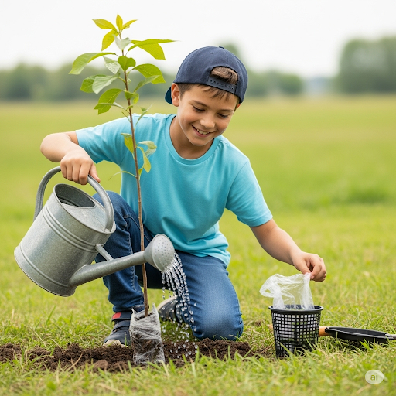**1. Picture 1:**

1. Did the boy plant a tree?﻿2. Did he use water to plant it?﻿3. Did he remove plastic before planting?﻿

(HOT)

4. Did the boy plant flowers?

5. Did the boy work alone?﻿

Q. 5 Answer the following questions based on the given picture (05)

My Neighbour’s activities of Last Sunday

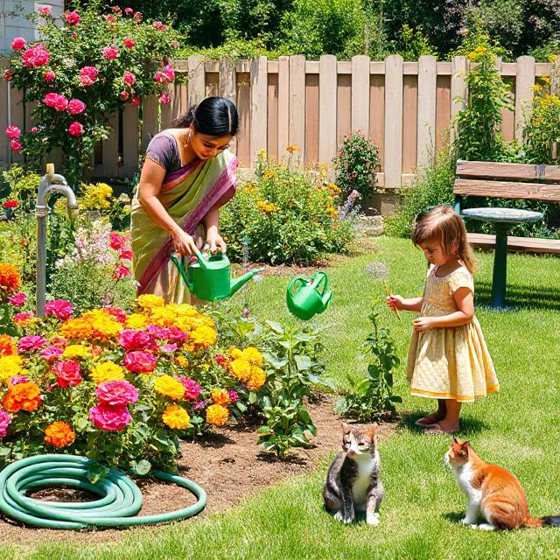**2. Picture 2:**

1. **Did the woman water the plants?**

2. **Did the girl stand near the flowers?**

3. Did the woman dig the soil with a spade?

4. Did they work in the garden?

5. **Did the girl pick a flower?**

Q. 6 Read the answer and write a correct question using “Did…” (10)

1. ________________________________________________ .

Answer: Yes, I went to the park.

2. ________________________________________________ .

Answer: No, he didn’t eat lunch.

3. ________________________________________________ .

Answer: Yes, I ate lunch at 1 o’clock.

4. ________________________________________________ .

Answer: Yes, they played football in the evening.

5. ________________________________________________ .

Answer: No, he didn’t visit his uncle last Sunday.

Q. 7 Change the following statements into questions using ‘Did’ (10)

1. She went to the park yesterday.

Answer: ____________________________________________________ .

2. She ate an apple.

Answer: ________________________________________________ .

3. They cleaned the classroom.

Answer: ________________________________________________ .

4. He watched a cartoon in the evening.

Answer: ________________________________________________ .

5. You brought your water bottle

Answer: ________________________________________________ .

Essay type questions

Q. 1 Respond the questions in such a way that help to write a paragraph on given following topic. (HOT) (10)

**1. My Yesterday**

1. Did you go to school yesterday?﻿
2. Did you read any book?﻿
3. Did you help your friend?﻿
4. Did you talk to your teacher?﻿
5. Did you finish your homework?﻿

**2. Last Sunday with my family**

1. Did your father go to work?﻿

2. Did your mother cook food?﻿

3. Did your brother/sister help at home?﻿

4. Did your family visit any place?﻿

5. Did you watch TV together?﻿

**3. My last year Annual Function Day** 1. Did you take part in the programme?﻿

2. Did your parents come to watch?﻿

3. Did you perform on stage?﻿

4. Did your teachers clap for you?﻿

5. Did you get any award?﻿

**4. Last year My School Picnic**

1. Did you go by bus?﻿

2. Did you visit any temple?﻿

3. Did you eat lunch outside?﻿

4. Did you play with your friends?﻿

5. Did you enjoy your picnic?﻿

**5. Last Week My Cousin’s Wedding**

1. Did you go to your cousin’s wedding?

2. Did you meet your relatives there?

3. Did you enjoy the food and music?

4. Did you wear special clothes?

5. Did you dance at the wedding?

**C.1.2પાઠ્યસામગ્રીને કાળજીપૂર્વક વાંચીને મુખ્ય મુદ્દા તારવે છે, ટુંકસાર જણાવે છે. અને સુસંગત રીતે પ્રતિભાવ આપે છે.**

**L.O.708 = આપેલા વિધાનોમાંથી અતાર્કિક શબ્દો તારવીને વિધાન સુધારે છે.**

Objective type questions

Q.1 Choose the most appropriate option. (15)

1. buy- bought catch-____________________

A.fought B. taught C. caught D. bought

2. We flew_____________ last Uttarayan.

A.book B. pencil C. kites D. eraser

3. My father ______________a painting.

A.draw B. drew C. play D. read

4. My friend, Mona____________ nice Bhajan.

A.sing B.ring C.sang D.play

5. Find the incorrect pair.

A.buy-bought B. play-played C. stop-stopped

D. Catch-catched

6. Find the correct for ‘know’.

A. blew B. knowed C. knew D. language

7. Find the odd one.

A. I buy a pencil. B. My mother bought jaggery.

C. My father bought a belt. D. My sister caught a butterfly.

8. Find out incorrect sentence.

A. My friend told me a story. B. Sonal bought a new dress.

C. Mayur stop a car. D. Bharat stopped the ball.

9. Find the correct sentence.

A. Pratham draw a beautiful picture.

B. Pratham is draw a beautiful picture.

C. Pratham drawing a beautiful picture.

D. Pratham drew a beautiful picture.

10. Find the incorrect pair.

A. play-played B. read-read C. fly-flew D.blow-blowed

11. Select correct alphabetical order.

A. bell, song, picture, bag B. angel, angle, read, ball

C. buy, catch, know, read D. angel, catch, read, bag

12. Identify incorrect pair

A. car-four wheel B. bicycle- handle C. auto rickshaw-pedal

D. bike-petrol

13. Which one is incorrect pair?

A. orange-green B. apple-red C. lemon-blue

D. watermelon-red

14. Odd one out.

A. motorcar B. auto-rickshaw C. motorcycle D. camel cart

15. Find the odd one.

A. Sunita Williams- astronaut B. Indira Gandhi – prime minister

C. Raanilakshami – warrior D. Latamangeshkar - actor

16. Identify incorrect pair.

A. mother- father B. grandmother – grandson

C. aunty – uncle D. brother – sister-in-law

Very short type questions

Q.1 Strike out the incorrect word. (05)

1. Payal played/play tabla.

2. Ramesh blow/blew whistle loudly.

3. My grandmother reads/read the Ramayana yesterday.

4. Rohit dropped/dropping a catch in the last match.

5. My uncle go/went to America last night.

Q.2 Fill in the blanks. (05)

Jigar had 500 rs. He went____________ (under/between/to) a cinema. He _______ (watches/watch/watched) ‘TaareJamin Par’. He paid 100 rs. for the ticket. In the interval, _______________ (she/he/they) bought two _______________ packetes/packet/packets) of popcorn. He _____ (pay/paid/pays) 50rs. for each packet.

Q.3 Choose the most appropriate words from column‘B’. (05)

**(A) (B)**

(A) go 1. went, goes, goen

(B) bring 2. bought, bringed, brought

(C) eat 3. ate, it, aet

(D) drive 4. dirve, drove, drived

(E) think 5. thought, throught,thot

Q.4 Choose the most appropriate words from column‘B’ (05)

1. **(B)**

(A) sleep 1.slep, sleeped, slept

(B) cry 2.cryed, cried, criyed

(C) see 3.seed, sew, saw

(D) speak 4.speaked, spoke, spoked

(E) write 5. wrote, rote, writed

Short type questions

Q.1 Strike out the incorrect word and rewrite sentence. (05)

1.Gandhiji is/was born on 2nd October.

2. Radha was/ is present on Tuesday.

3. The decoits come/ came that night.

4. Chhotu and Motu loving/ loved swimming.

5. Ramesh and Suresh was/ were in the hospital last week.

**Q.2 Rewrite the sentence using the word given in the bracket. (05)**

1. Shweta was present on Monday. (Nirali and Usha)

2. Anil was at his farm last Sunday. (Ramesh and Magan)

3. All students were happy. (My friend)

4. Kusum cooked ‘dal-baati’ yesterday. (My mother)

5. Nirav told a story in prayer-assembly. (Our English teacher)

Essay type questions

Q.1 Replace the underline words from the bracket and rewrite the paragraph. (05)

(invited, gave, friends, cage, house,)

A sparrow and a parrot were good **brothers**. Every day they talked with each other. The parrot lived in a cage in Parul's **class**. The sparrow lived in a tree. Parul **bought** the parrot good food. The sparrow worked for food. Once the parrot **invite** the sparrow to come into his cage and share his happiness. The sparrow said, 'No'. She was very happy outside the **cave**. The parrot also wanted to come out of the cage. So the sparrow helped him to open the cage. Both the friends flew away in the open sky.

Q.2 Strick out inappropriate words and rewrite the passage. (05)

Winter is a pleasant season. Generally, it starts in March/ November and ends in February. During winter, months/ days are shorter and nights are longer. People wear cold/ warm clothes. We celebrate Diwali, Uttarayan/ Holi, Christmas, Vasant Panchami, and New Year during winter. Many places get snow which covers the ground in white. In Kutch, Ranotsav is celebrated during winter/ summer.

**C.2.2 પોતાની આસપાસના સામાજિક અને સાંસ્કૃતિક વાતાવરણના વિવિધ પાસાઓ પર પોતાના વિચારો અને વિવેચનાઓની મૌખિક અને લેખિત રજૂઆત કરે છે.**

**L.O.715 પરિચિત પરિસ્થિતિમાં સંવાદ કરે છે.**

Objective type questions

Q.1 Choose the most appropriate option. (15)

1. Teacher: _________ is your name?

Student: My name is Sunny.

1. Who B. Where C. What D When
2. Where do you__________?
3. live B. will live C. lived D. was live

3. Meena: Beta, what did you________ in the school today?

Son: Mummy, I learnt about God Shankar today.

A. learnt B. learned C. were learn D. learn

4. Father: Shweta, did you have snacks?

Shweta: No, Papa.I______snacks.

A. doesn't have B. didn't have C. did have D. didn't had

5. Ram: What are you doing, Laxman?

Laxman : _________________.

A. I am doing homework.

B. I doing homework.

C. I am do homework.

D. I do homework.

6. Teacher: Hello, Good morning. How are you?

Student: ____________and you?

A. I fine B. I was fine. C. I am fine. D. I will fine.

7. Shankar: _________old are you?

Shambhu: I am 60 years old.

1. How B. Why C.What. D.How many

8. Teacher: Did you go to the temple in the morning?

Student: __________________.

1. Yes, I did.
2. No, I did.
3. Yes, I didn't.
4. No, I did do.

9. Father:_________________?

Daughter: I visited the garden yesterday.

A. Where did you go yesterday?

B. Where do you go yesterday?

C. Where will you go yesterday?

D. Where does you go yesterday?

10. Change the underlined word with correct one:

Where did you lived?

A.leave B.live C.does live D.not lived

11. Change the underlined word with correct one:

Did you distributed chocolates?

A.did distribute B.will distribute C.distributes D.distribute

12. Change the underlined word with correct one:

I enjoyed the cricket match tomorrow.

A. next Sunday B. next week C. yesterday D. next month

13. Teacher: Why didn't you do your homework?

Student: ________________.

A. I was sick.

B. I shall sick.

C. I will sick.

D. I were sick.

14. Anita: Did you take part in the bicycle race?

Sneha: __________________.

A. Yes,I take part.

B. No, I do not take part.

C. Yes, I took part.

D. No, I didn't took part.

15. Dr Bhatt gave tablets to the patient.

____________________? Yes, he did.

A. Did Dr Bhatt gave tablets to the patient?

B. Did Dr Bhatt give tablets to the patient?

C. Did Dr Bhatt gives tablets to the patient?

D. Did Dr Bhatt will give tablets to the patient?

Q.2 Change the underlined word with correct one. (05)

(1) Who do you live? (Where/ When/ What)

(2) Did you drew a picture? (draw/ drew/ drewen)

(3) Did he dance? Yes, he did danced. (danced/ dance/ didn’t danced)

(4) May I came in, sir? (come/ came/ didn’t came)

(5) What are you late today? (Where/ Why/ When)

Q.3 Match ‘A’ with ‘B’ (05)

A B

1. Which subject do you like most? (A) I went to my uncle’s home.
2. Did you do your homework? (B) Yes. I enjoyed the film.
3. Why were you absent yesterday? (C) I like English.
4. Where do you live? (D) Yes, I did my homework.
5. Did you enjoy the film? (E) I live IN Ahmedabad.

Very short type questions

Q.1 Complete the dialogue with the words given in the bracket. (05)

(I am fine, please, your mother's mobile number, sorry, good morning)

Meena : _________,Shweta.

Shweta: Good morning, Meena.How are you?

Meena: _________. Give me your mobile number _________.

Shweta: I have no mobile phone, ________.

Meena: Ok.Give me_____________.

Shweta: Here it is.

Q.2 Complete the dialogue with the words given in the bracket. (05)

(medicine store, misunderstood, where, no, next time)

Sunny: _______did he go?

Kishan: He went to the medical store.

Sunny: To the grocery store?

Kishan: ________.I said he went to the ___________.

Sunny: Oh,I ______you. Sorry.

Kishan: OK.Listen carefully __________.

Q.3 Select the proper questions from the options given below. (05)

Teacher: _______(1)_________?

Student: My name is Tina.

Teacher: _________(2)_______?

Student: My Classroom is near the sport room.

Teacher: ______(3)__________?

Student: I missed the train and that’s why I am late.

Teacher: ______(4)__________?

Student: Yes, Sir. I missed the train yesterday, too.

Teacher: _______(5)_________?

Student: No, Sir. I got up very early but I went to shop to help my father.

**Questions:**

1. (a) Is this your name? 4. (a) Were you late yesterday?

(b) What is your name? (b) Why were you late?

(c) Where is your name? (c) Where were you late?

2. (a) Which class are you in? 5. (a) Will you get up late?

(b) Where is your class? (b) Do you get up late?

(c) Why are you there? (c)Did you get up late?

3. (a) Are you late?

(b) How are you late?

(c) Why are you late?

Short type questions

Q.1 Complete the dialogue. (10)

Teacher: What is your name?

Student: ________________.

Teacher: Where do you live?

Student: ________________.

Teacher: How old are you?

Student: ________________.

Teacher: Which game do you like to play?

Student: ________________.

Teacher: Do you like to watch television?

Student: ________________.

Q.2 Complete the dialogue. (10)

Tina: Do you like to go to school?

Mina: ________________.

Tina: Do you like to eat fruits?

Mina: ________________.

Tina: Which fruit do you like?

Mina: ________________.

Tina: What did you eat in your breakfast yesterday?

Mina: ________________.

Tina: When do you play?

Mina: ________________.

Q.3 Complete the dialogue. (10)

Tourist: Excuse me!

Villager: ________________?

Tourist: Is there a medical shop nearby?

Villager: Yes, ________________.

Tourist: ________________ the way to the medical store?

Villager: Yes, ________________.Go straight and then take a right turn.

Tourist: Thank you very much.

Villager: ________________.

Essay type questions

Q.1 Prepare the dialogue between a teacher and a student. (10)

Q.2 Arrange the dialogues in the correct order: (05)

1. It is at 11:00 p.m.
2. Thank you very much
3. Platform no.1
4. When is the train to Anand?
5. Which platform?

Q.3 Prepare the dialogue as per the given information: (05)

Meena went to the fruit shop to buy fruits. She asked the shopkeeper for fruits.

Meena : Do you have apples and bananas ?

Shopkeeper : ______, how many bananas do you want?

Meena: _____________.

Shopkeeper : How much apples do you want?

Meena:________________.

Shopkeeper: ___________.

Meena: ____________.

Q.4 Create your own dialogue with your friend. (10)

Q.5 Prepare the dialogue between father and son about the tour of the school with the help of given clues. (HOT) (10)

Clues – when – with whom- how – what did you see ?

**C.1.2 પાઠ્યસામગ્રી ને કાળજી પૂર્વક વાંચીને મુખ્ય મુદ્દા તારવે છે, ટુંકસાર જણાવે છે. અને સુસંગત રીતે પ્રતિભાવ આપે છે.**

**L.O.- 7.20 વાંચન અને ઉચ્ચાર વચ્ચેનો ભેદ તારવે છે.**

Objective Type Questions

Q.1 Choose correct option for the following questions . (05)

1. Find correct rhyming word for 'flew'.  
 A. fly B. blew C. bought D. caught

2. Find correct pair .

A. red-rang B. rang-sang C. little – whistle D. song- sang

3. Find incorrect pair

A. knew- drew B. flew-blew C. bought- caught D. sing - sang

4. Fill in the blanks using correct rhyming word.

This is the bell the little one rang

This is the song the little one ________

A. read B. sang C. drew D. knew

5. Find the odd one.

A. bought B. caught C. buy D. taught

6. Which rhyming word is matched with ‘bunch’ ?

A. fetch B. catch C. match D. lunch

7. Which rhyming word is not matched with the word ‘spice’ ?

A. vice B. mice C. twice D. rose

8. hill, bill, kill ______________

A. mile B. tall C. will D. style

9. A rhyming word that match with the word ‘knew’ is _________

A. clue B. drew C. blue D. know

10. A rhyming word which does not match with the word ‘food’ is _________

A. mood B. hood C. good D. feed

11. Which pair of rhyming words is correct ?

A. catch-caught B. fly- flew C. sang - rang D. sing-sang

12. Which group of words shows rhyming words

A. sang, rang, sing,

B. read , red , lead ,

C. fought , caught , bought

D. knew , know , known

13. Find correct rhyming word for the word ‘tight ‘ .

A. fought B. taught C.fight D. side

14. Find incorrect rhyming word for the word ‘catch ‘.

A. match B. batch C. bench D. fetch

15. Find the odd one.

A. flew B. blew C. knew D. blue

Q.2 Choose correct rhyming word from the words given in the bracket . (05)

[ knew , round , fought , bed , rang]

1. _________ is a rhyming word for the word ‘caught’

2. ________ is a rhyming word for the word ‘red’

3. ________ is a rhyming word for the word ‘view’.

4. __________ is a rhyming word for the word ‘sang’

5. _________ is a rhyming word for the word ‘found ’

Q.3 Match the following . (05)

**A B**

1. round A. sing

2. licked B. ground

3. drew C. faught

4. ring D. picked

5. taught E. view

Very Short type questions

Q.1 Write a rhyming word for the following words. (05)

1. caught __________

2. red __________

3. view __________

4. sang __________

5. found __________

Q.2 Fill in the blanks . (05)

1. This is the bag the little one bought

This is the butterfly the little one _________

2. This is the kite the little one flew

This is the whistle the little ones _________

3. These are the pictures the little one ____________

All these things the little ones knew

4. This is the bell the little one ________

This is the song the little one sang

5. White and black and green and red

All these words the little ones ___________

Short type questions

Q.1 Read the poem and answer the questions (10)

This is the ball the little friend found ,

This is the ant that runs on the ground .

This is the flower the little friend picked

This is the ice-cream the little friend licked .

This is the ball the little friend found

This is the ant that runs on the ground .

Green and blue and yellow and brown

These are the colours learned in the town.

These are the games the little friend played

All these memories the little friend made .

**Questions;**

1. Find a rhyming word for the word ‘kicked’ from the poem .

2. A word that matches with the word ‘played’ is ____________

3. Which rhyming word is matched with the word ‘town ’ ?

4. ‘Brown’ is the rhyming word for ‘town’ . True / False

5. Write any two rhyming words for the word ‘round ‘ .

Q.2 Write two rhyming words for the following words. (10)

1. fought - __________ __________

2. sing - __________ __________

3. lunch- __________ __________

4. food - __________ __________

5. flew - __________ __________